***Name:*** Ruppa Giridhar

***Roll.no:*** 07

***Reg.no:*** 122207968

----------------------------------------------------------------------

SHA256 hash: 3c0ae906bacae796e85d02b2b054f85e38b3d3c4ac502f26f39fea04b7061b4e

File name: Nyetnpntg.exe

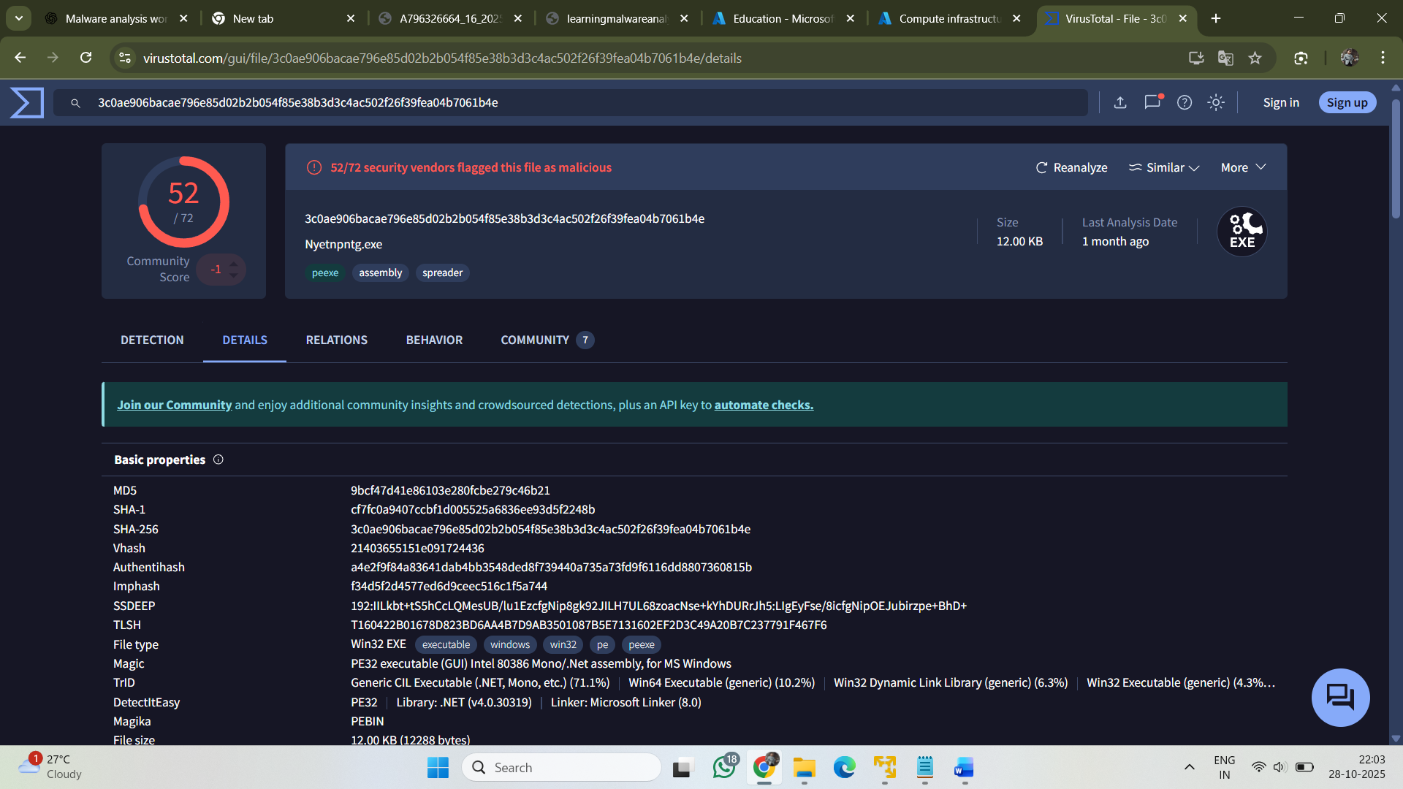

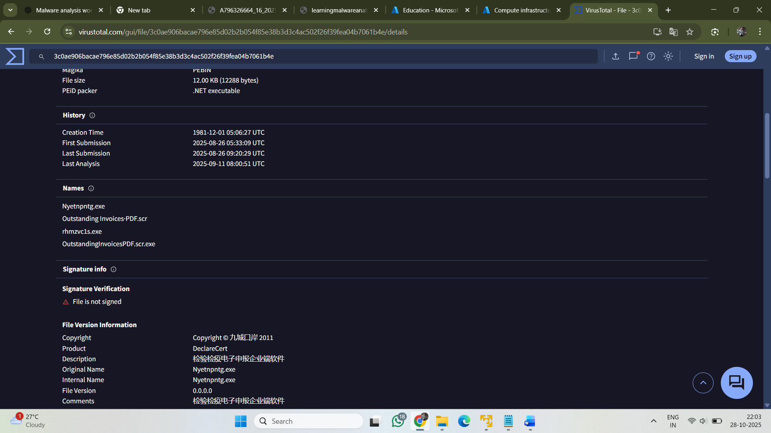

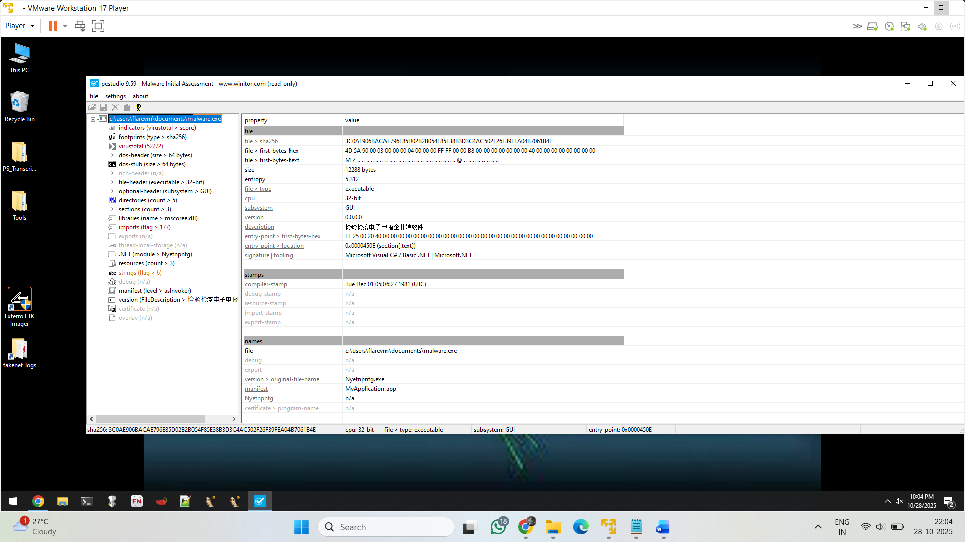

This is a **32-bit Windows executable (GUI)** compiled with **Microsoft Visual C# / .NET**, indicating a **managed .NET application**.  
The **entry point** lies in the .text section, calling the CLR (_CorExeMain).  
It shows a **SHA-256 hash** of 3COAE906BACAE796E85D02B2B054F85E38B3D3C4AC502F26F39FEA04B7061B4E,  
a **file size** of **12,288 bytes**, and an **entropy** value of **5.312**, suggesting a normally compressed or lightly obfuscated binary.  
No valid **certificate** or **debug symbols** are present, and the original file name appears as **Nyetnpntg.exe** with internal app name **MyApplication.app**.

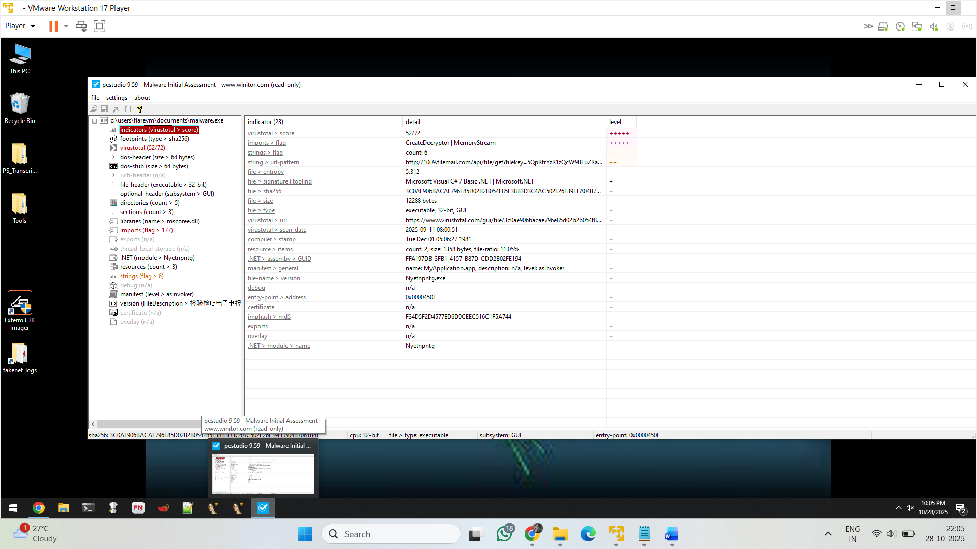

• **VirusTotal Scan Date:** 2025-09-11

• **Suspicious URL:** http://100@.filemail.com/api/file/get?filekey=5QpRtrYzR1zQcW9BFuZRa

• **Malicious Functions Identified:** CreateDecryptor, MemoryStream — suggest encryption/decryption behavior

• **.NET Assembly GUID:** FFA197DB-3FB1-4157-B87D-CDD2B02FE194

• **Resource Section:** 2 items, total 1358 bytes (ratio: 11.05%)

• **Compiler Timestamp:** Tue Jan 01 1981 (likely falsified to evade analysis)

• **Import Hash (ImpHash):** F34D5F2D4577ED6D9CEEC516C1F5A744

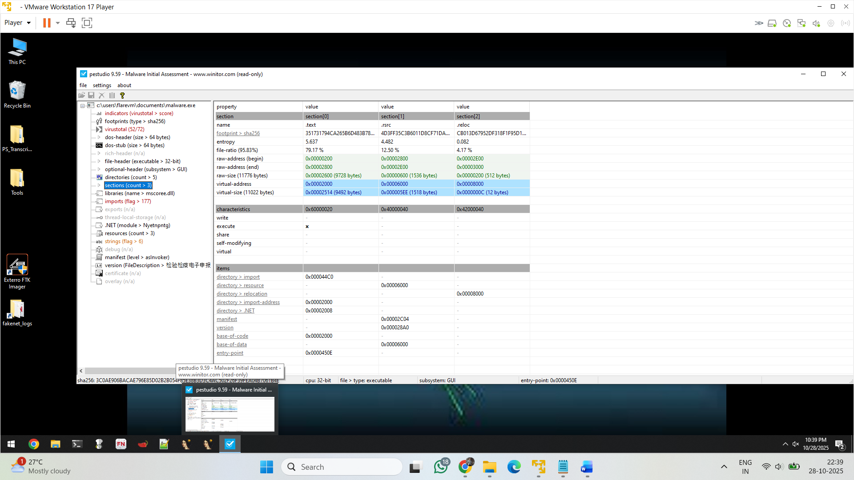

It execute the application

In above picture we can see that entry point i.e **0x0000450E**

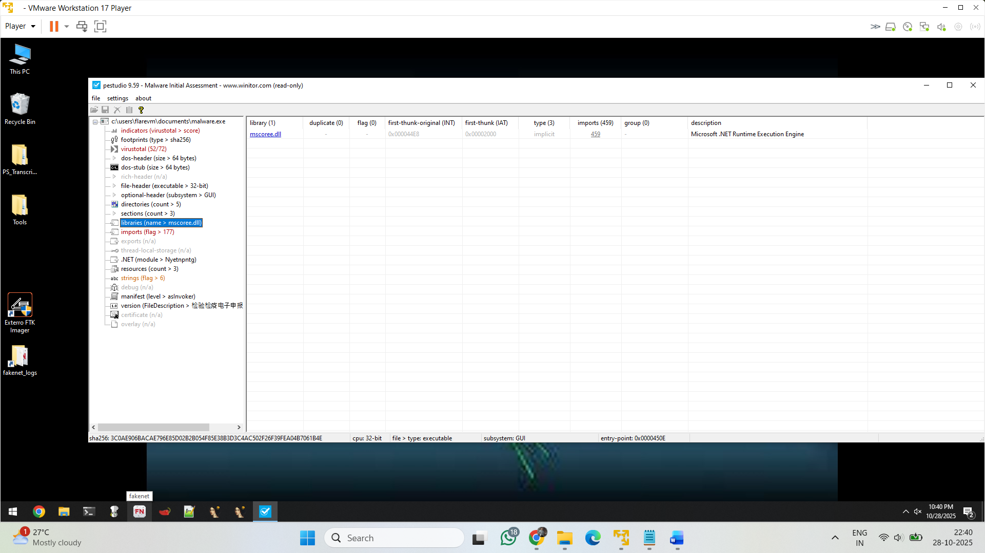

**Import Library:** mscoree.dll — Microsoft .NET Runtime Execution Engine.

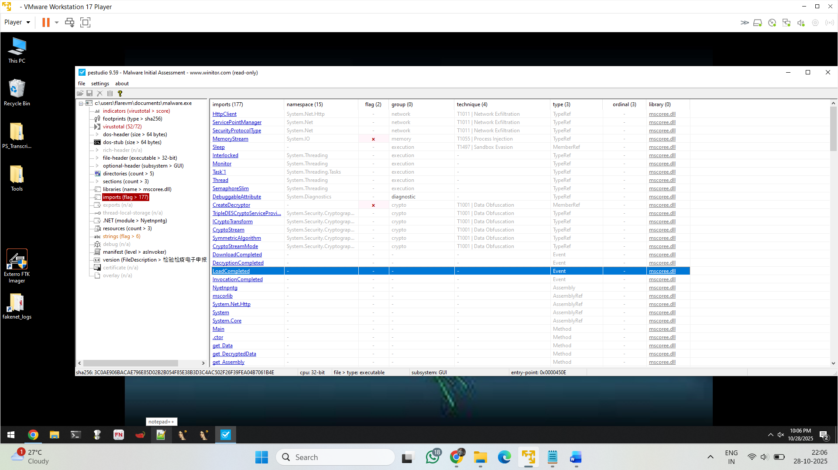

In above we see some API calls i.e HTTPclient , createDecrypter etc..

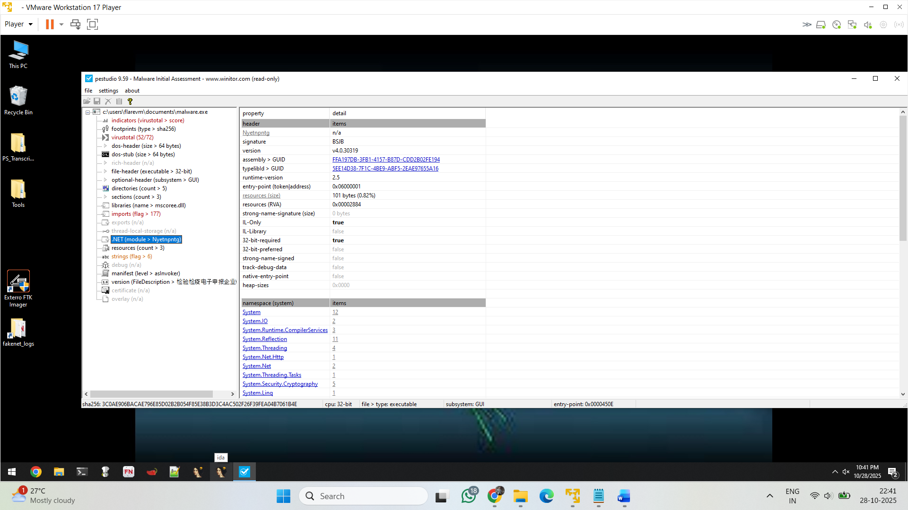

Check the namespace that uses the system , system.io , runtime ,.net etc

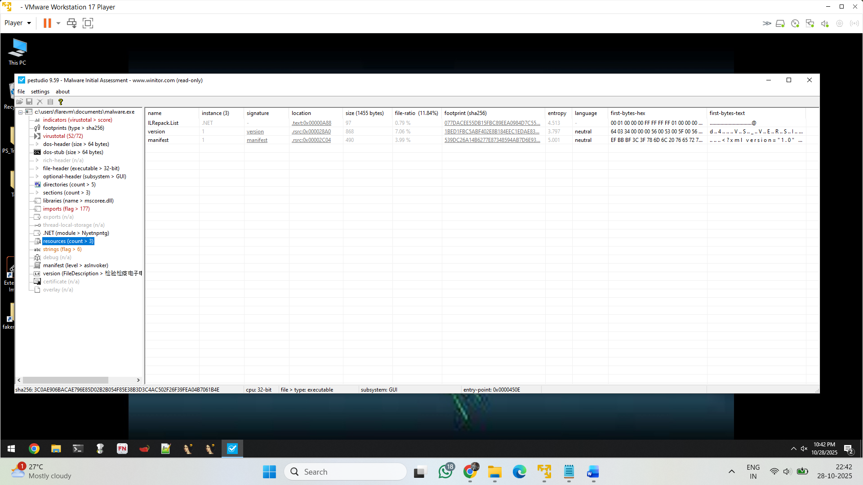

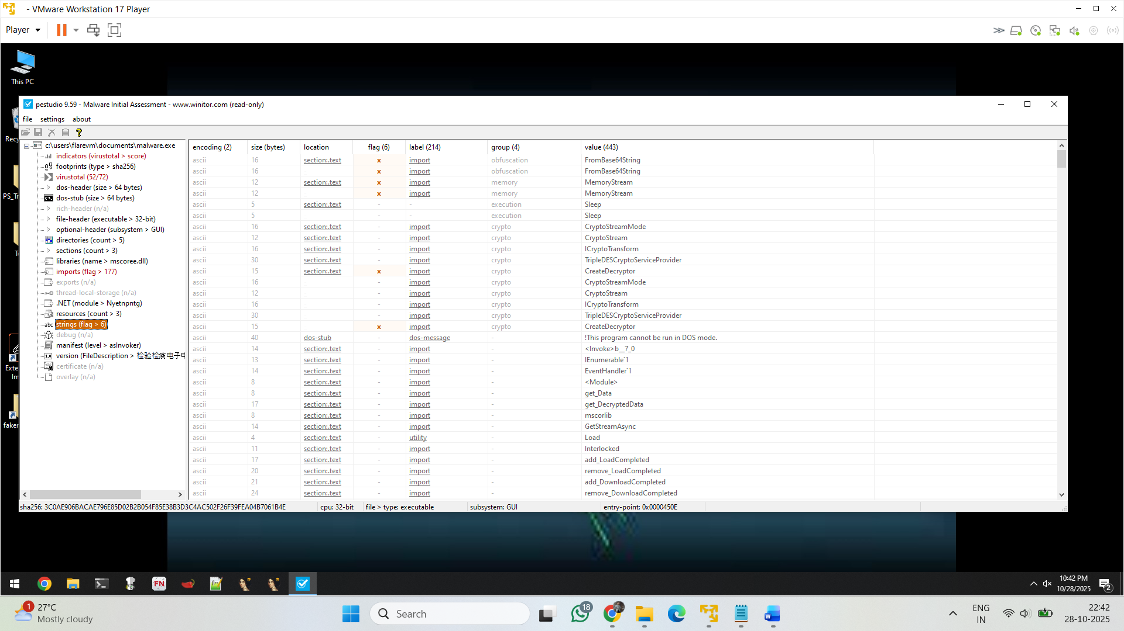

Here it import the createDecrypter from section.text

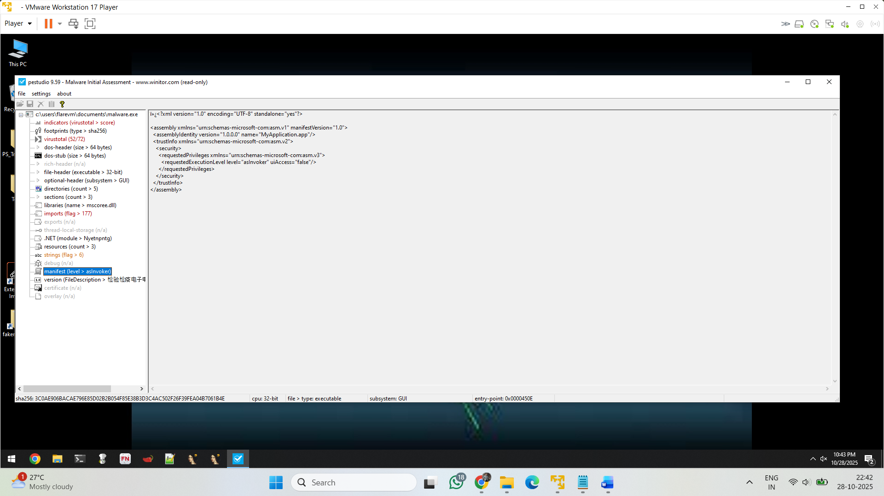

This is the manifest file

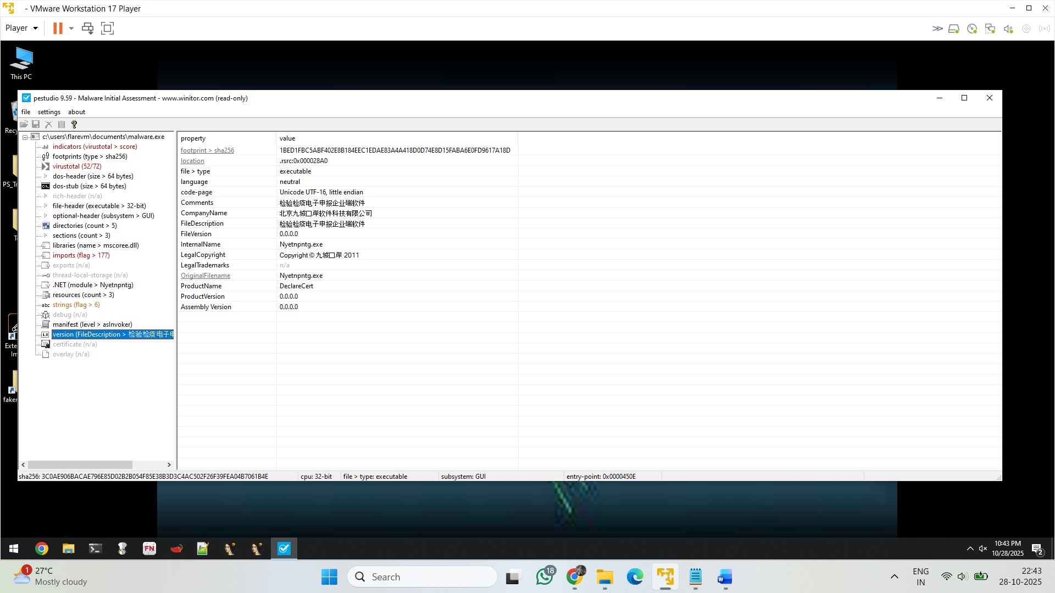

Above one tell , file is executable , sha , location etc

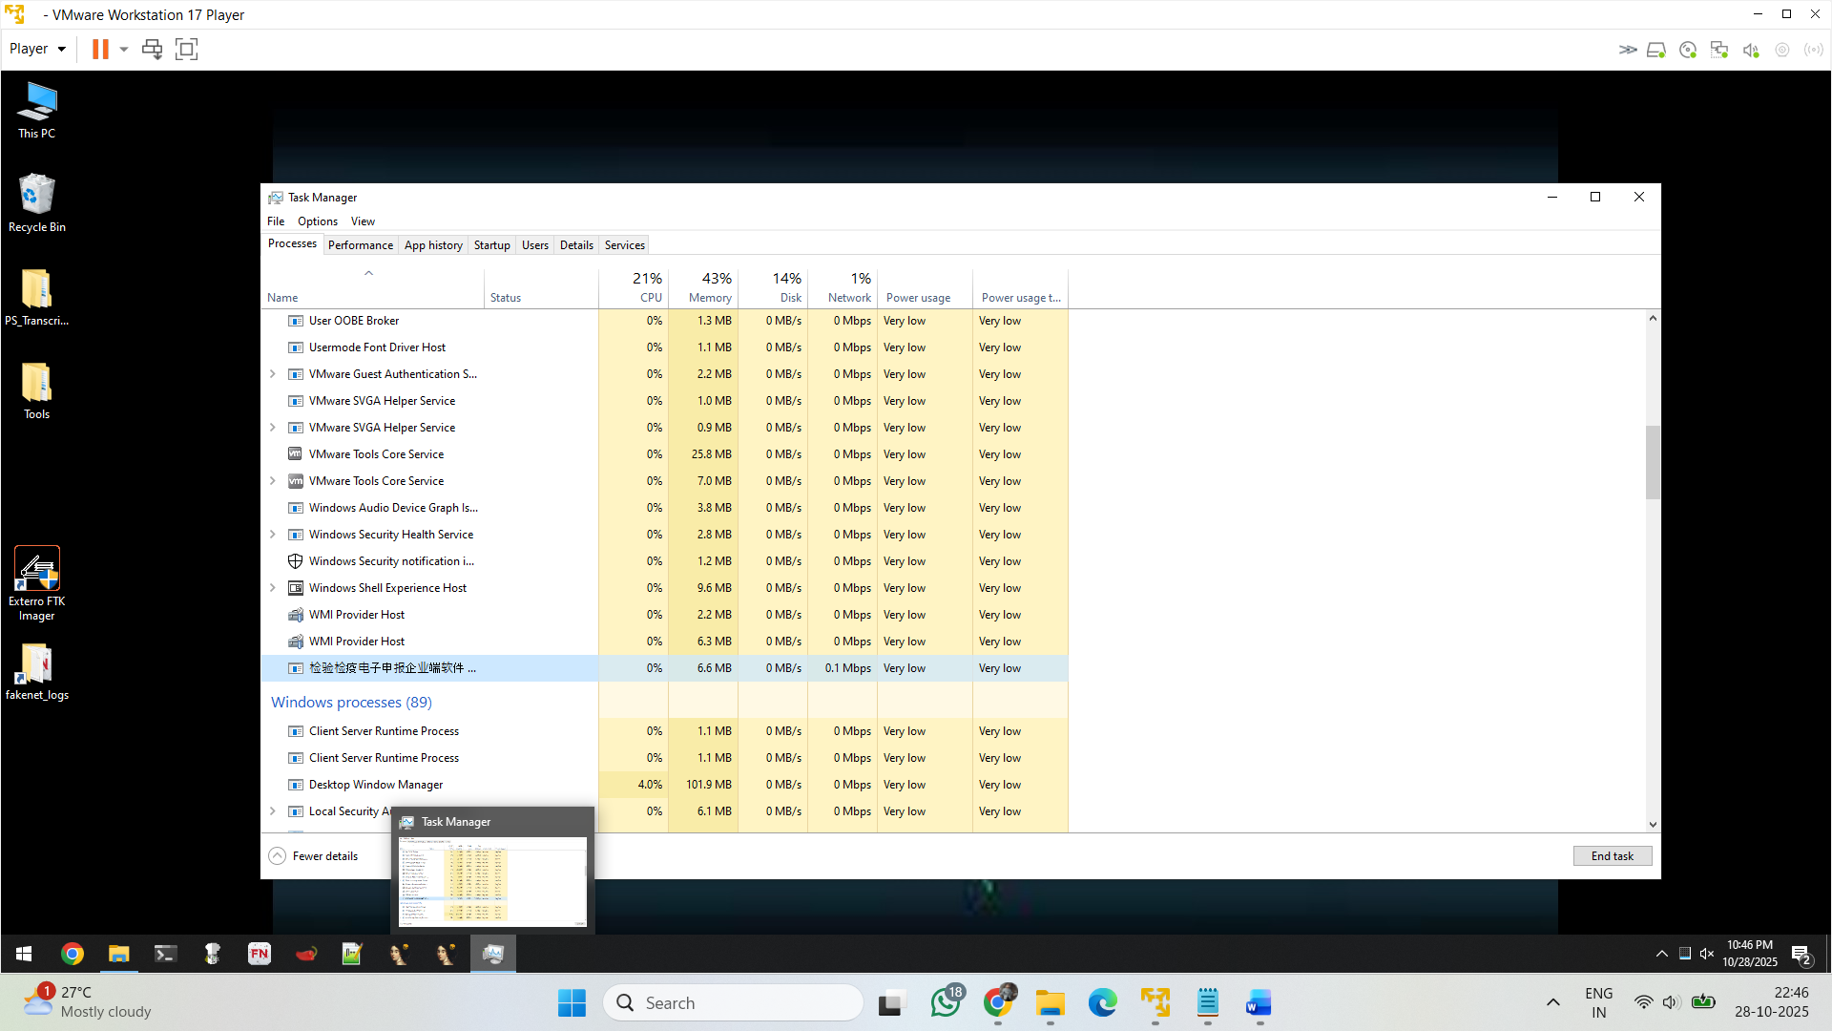

I execute the malware

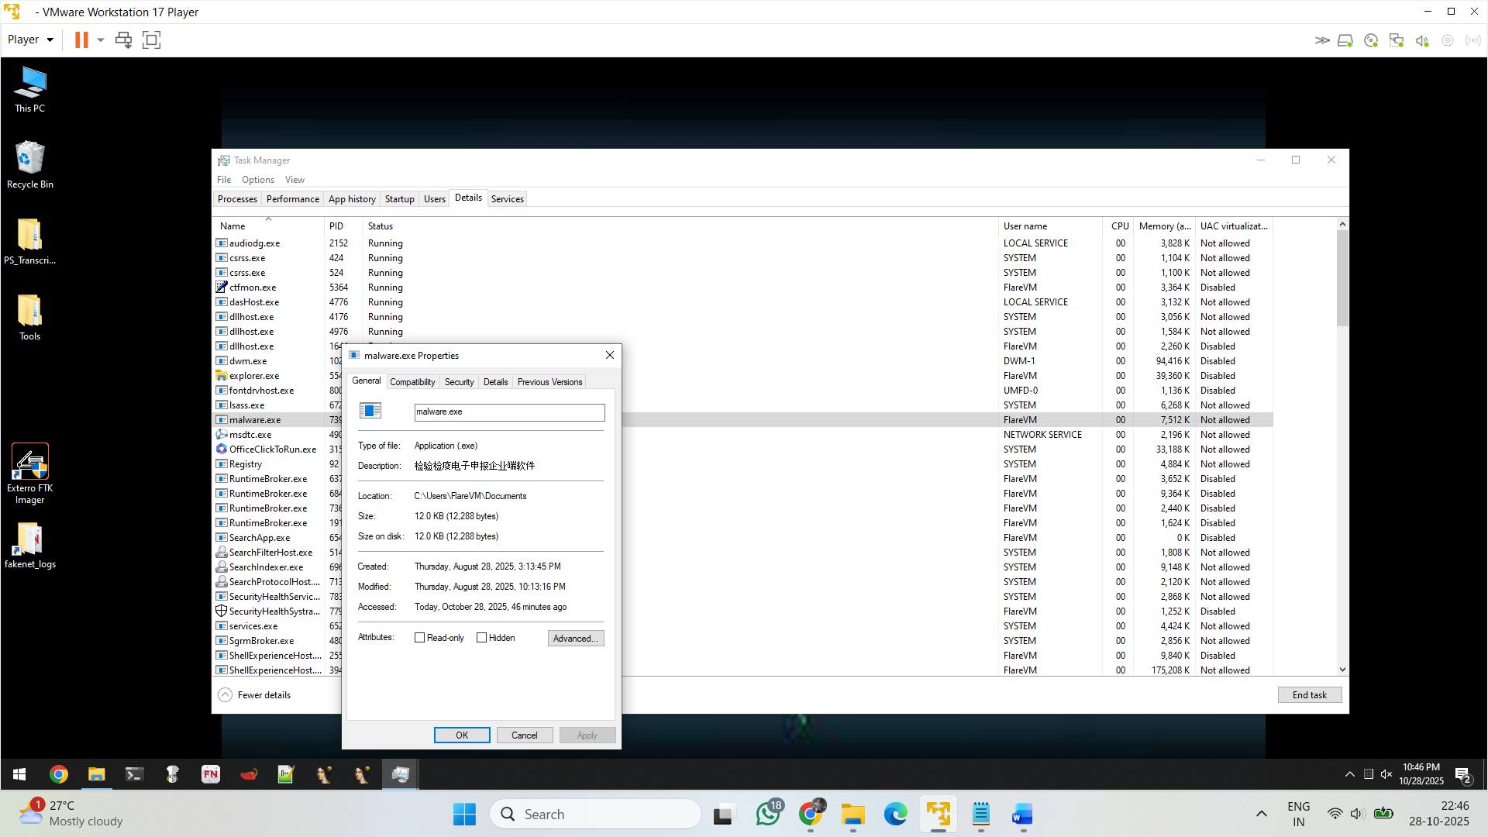

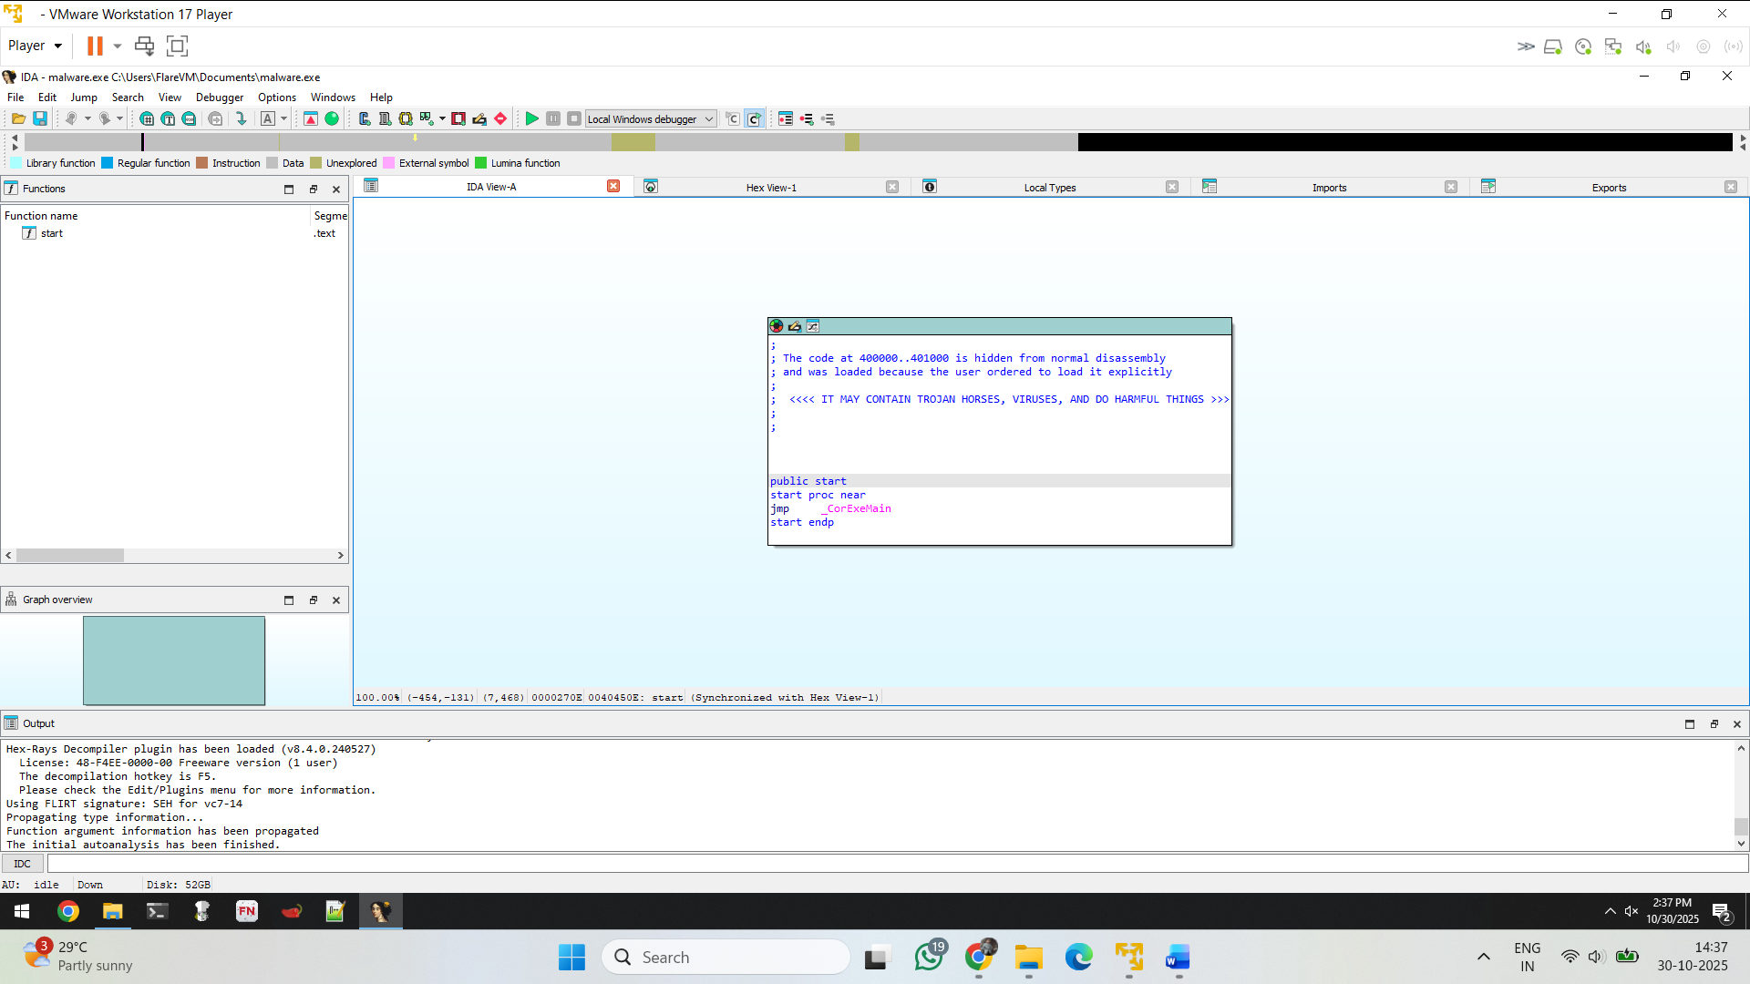

Here I the malware jumps to _CoreExeMain – in here main hidden reference is there

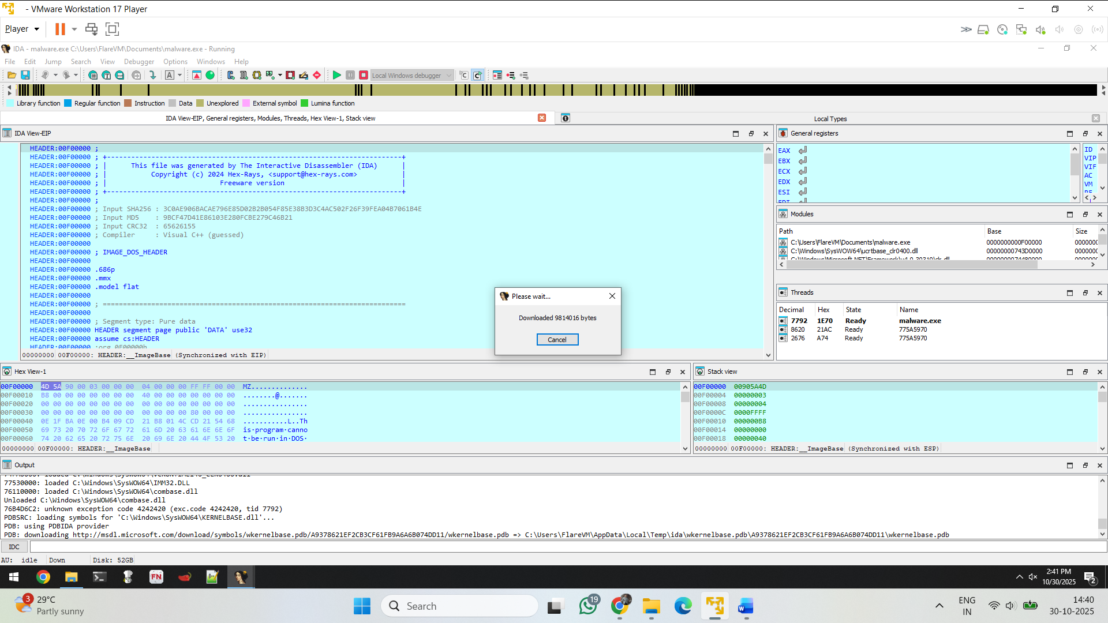

• **Analysis tool:** IDA Pro (Interactive Disassembler) — Freeware 2024.

• **Hex-Rays plugin:** Hex-Rays Decompiler present.

• **DOS stub:** Contains standard message "This program cannot be run in DOS mode."

• **Input SHA-256 (as provided earlier):** 3C0AE906BACAE796E85D02B2B054F85E38B3D3C4AC502F26F39FEA04B7061B4E.

• **Input MD5 (as provided earlier):** 9BCF47D41E86103E280FCBE279C46B21.

• **Input CRC32:** 65626155.

• **Guessed compiler/tooling:** Visual C++ (guessed).

• **PE architecture/model:** 32-bit, flat model.

• **Segment type:** DATA segment present (pure data).

• **IDA views used:** Hex view, Stack view, Registers (EIP/EAX/ECX/EDX/ESI shown).

• **Threads observed (TIDs):** 7792, 3620, 2676 (thread names/handles like 775A5970).

• **Debugger event:** unknown exception code **4242420** (anti-analysis / custom exception).

• **PDB behavior:** IDA attempted PDB download from Microsoft symbol server (msdl.microsoft.com) using PDBIDA provider.

• **PDB local cache path:** user temp path used (e.g., C:\Users\FlareVM\AppData\Local\Temp\ida\...).

• **ImageBase referenced / synced in views:** ImageBase synchronization noted (0x400000)

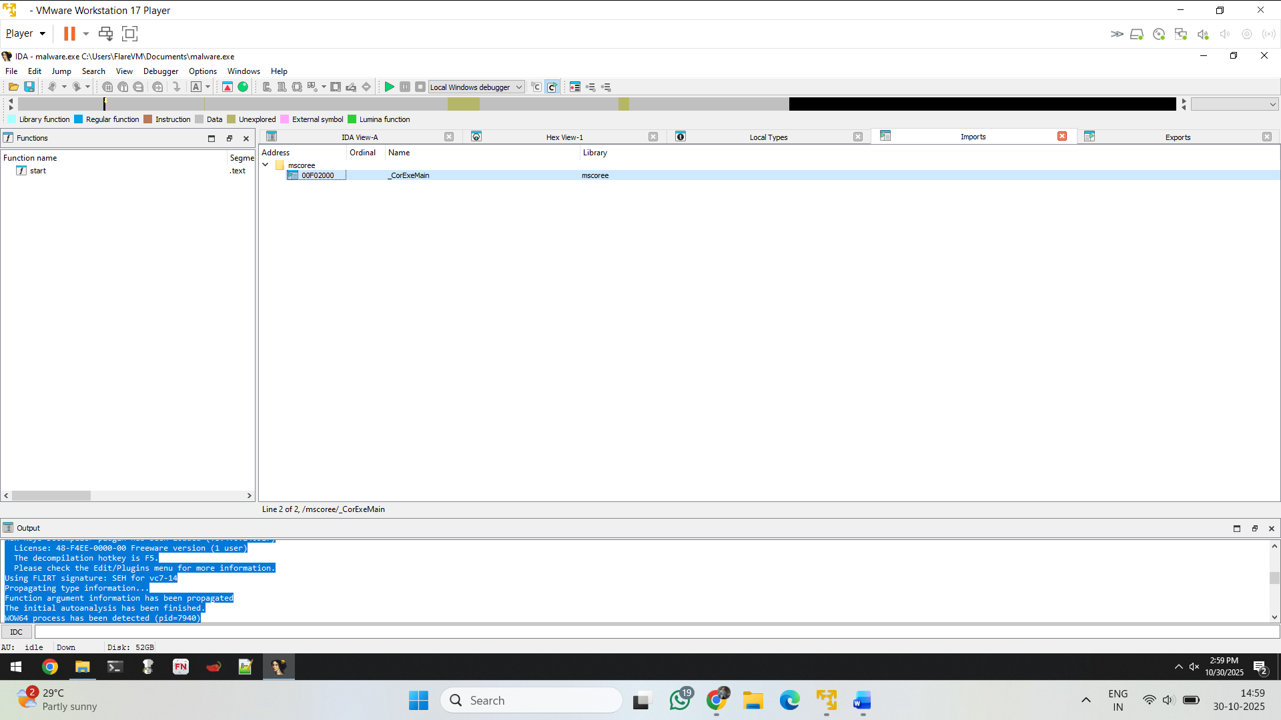

When the application jumps to corExeMain – it uses the mcscore.dll

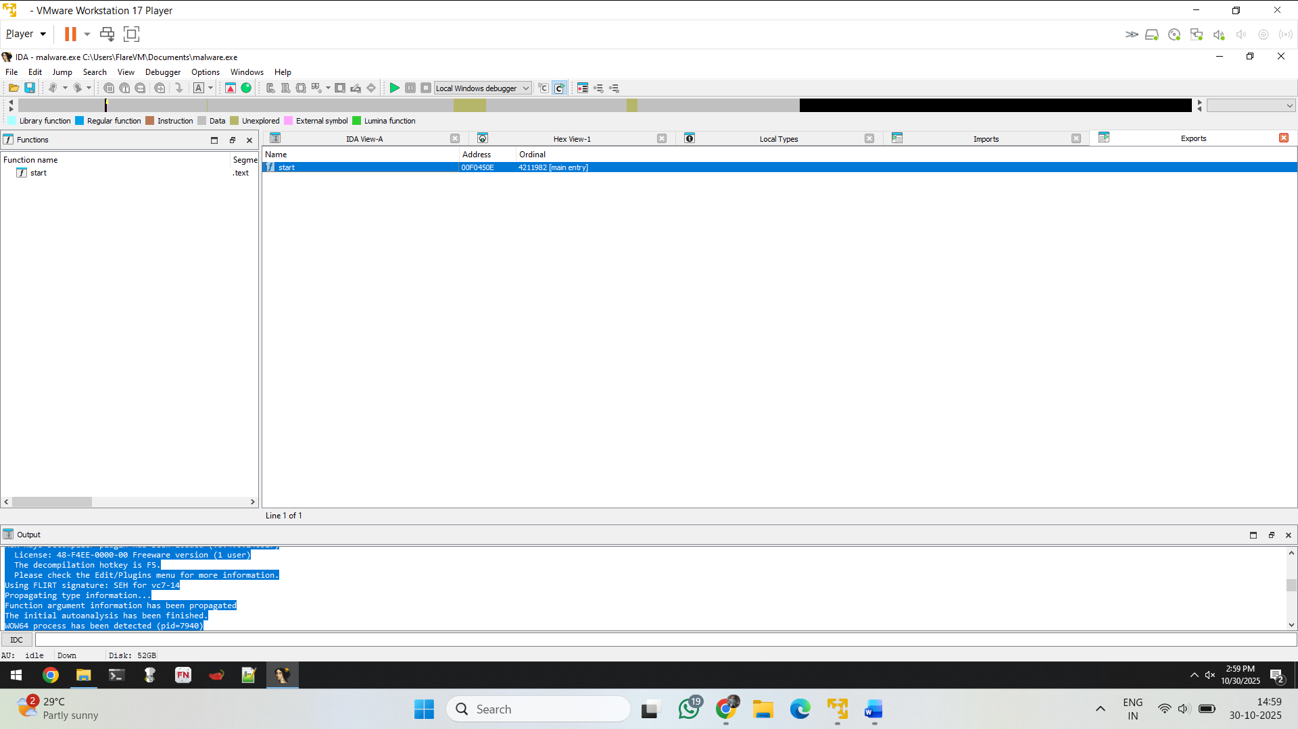

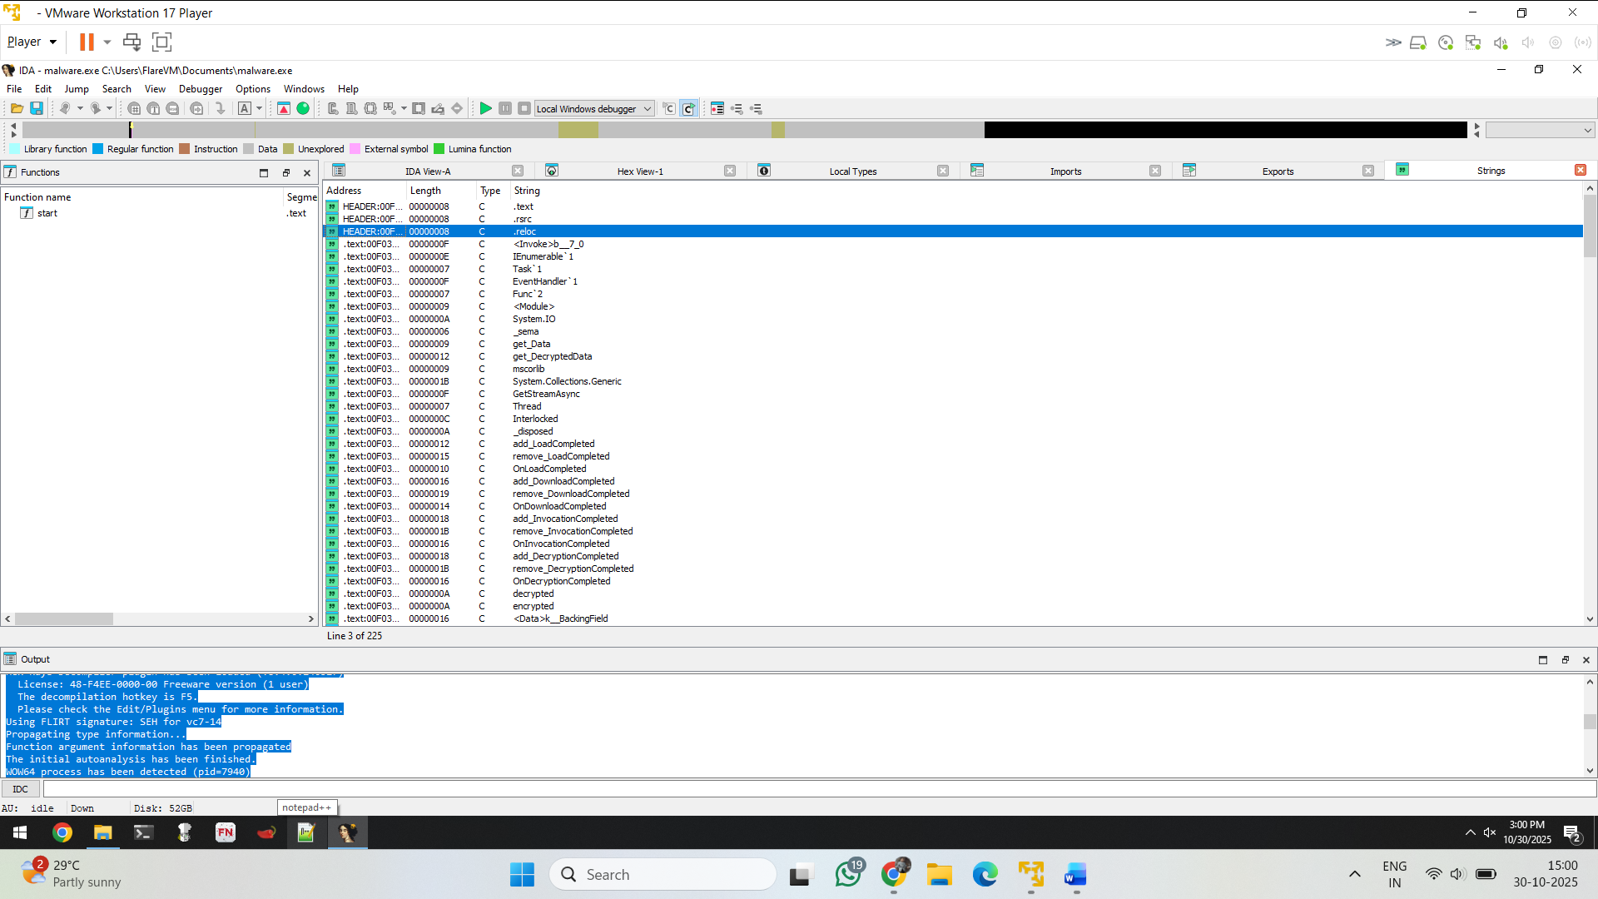

In above screenshot some strings visible that some of them are system calls and some are API

Eg : thread , get_Data etc..

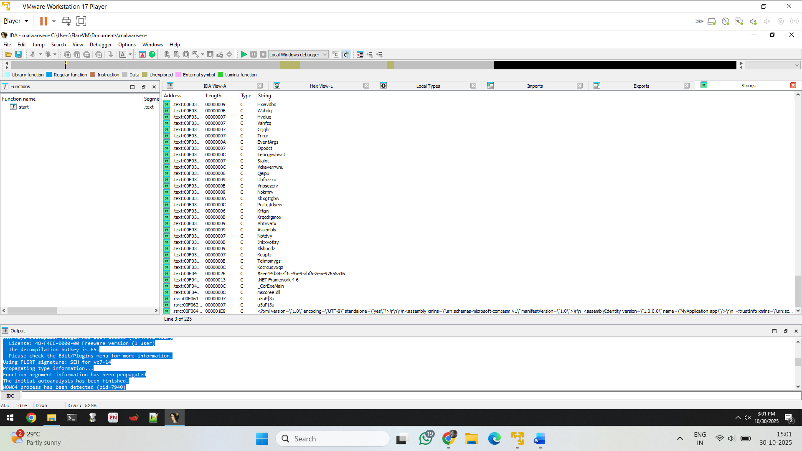

Below tin screenshot we can see the strings i.e manifest file, library mcscore.dll, .corExeMain

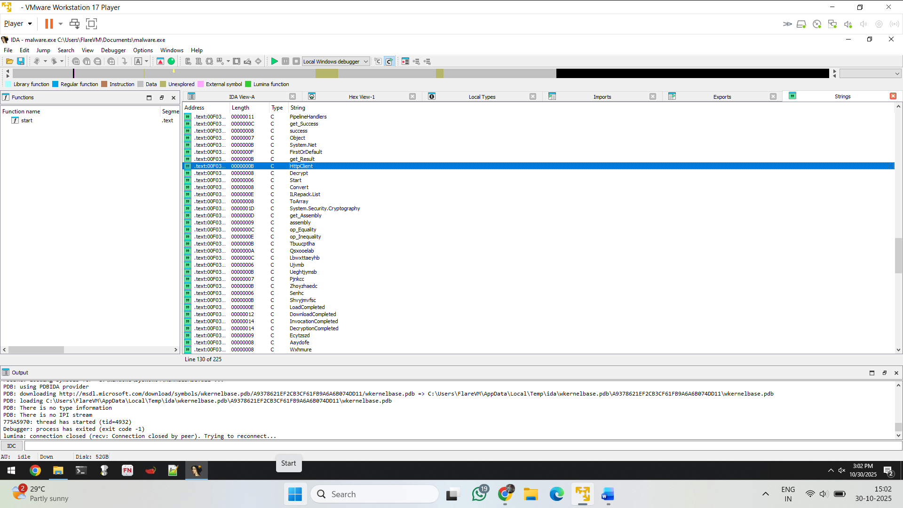

Some api calls httpclient

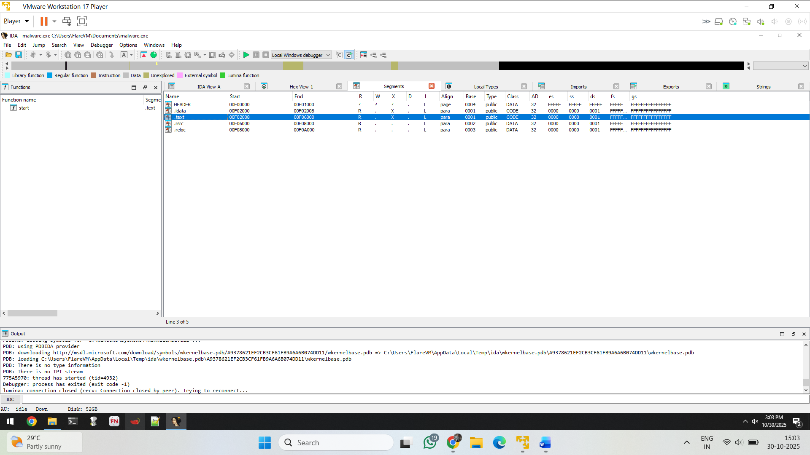

Start and end address of the application

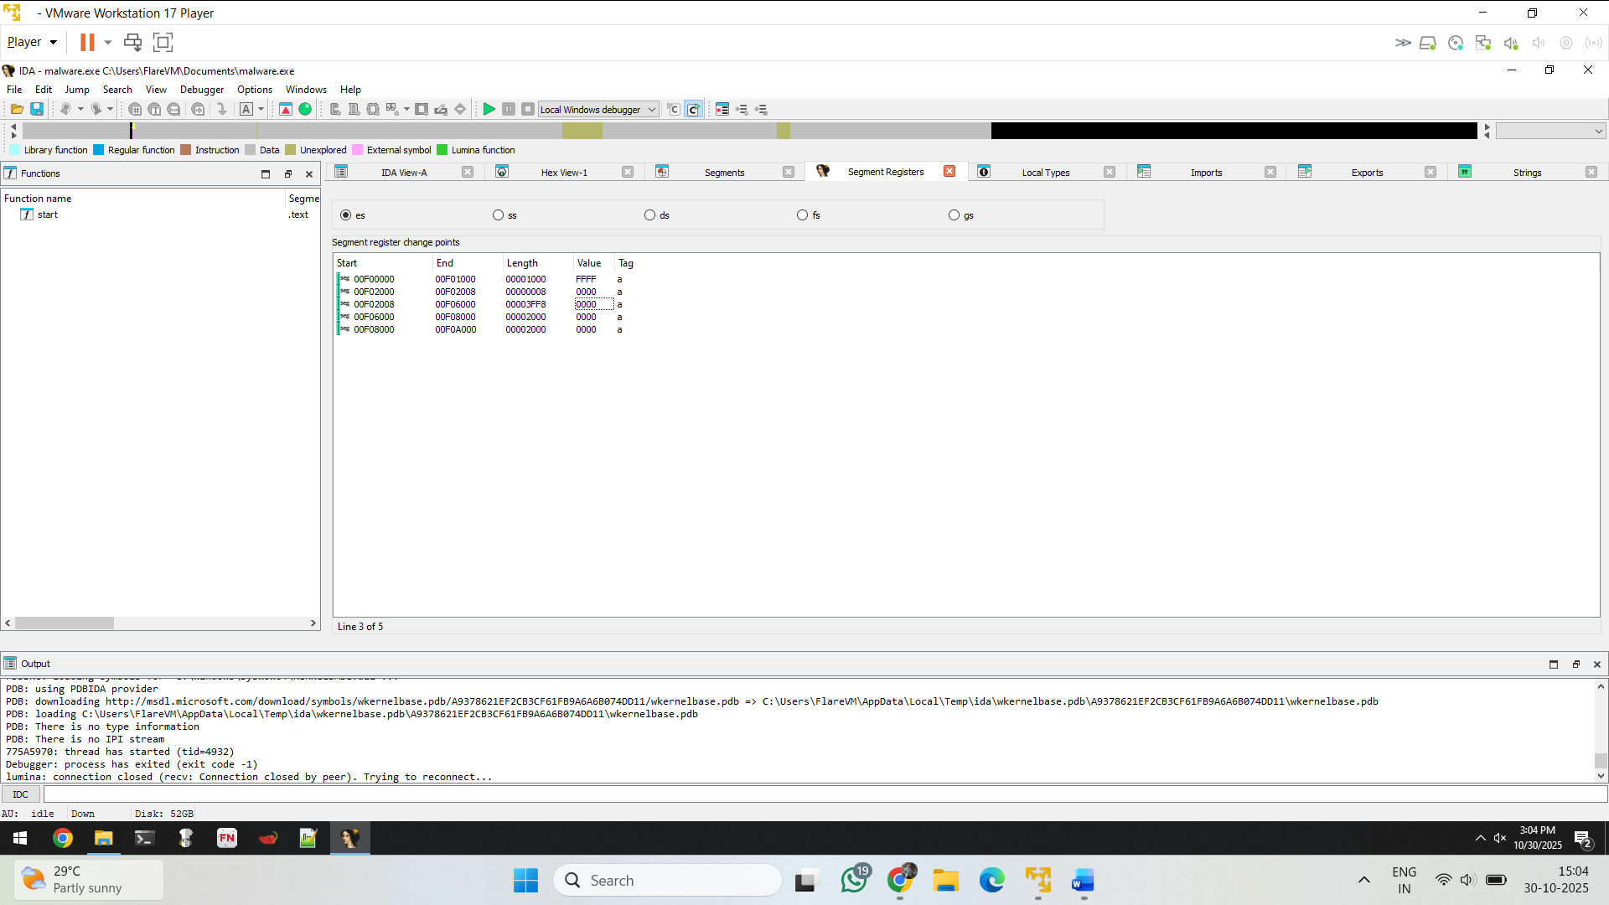

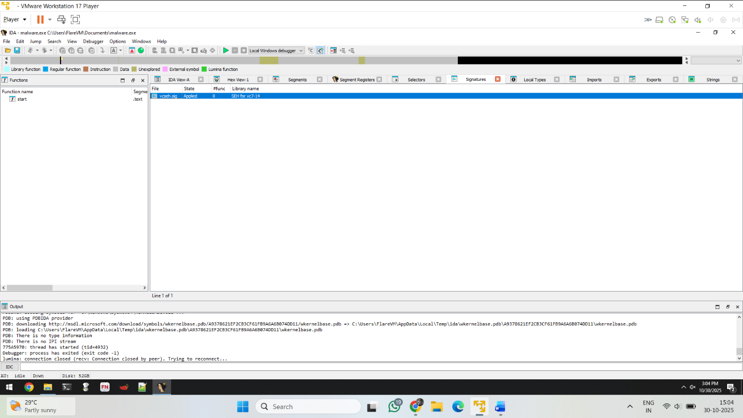Register entries and tag

Here the signatures of the file vcseh,org and library name is SEH for vc7-14

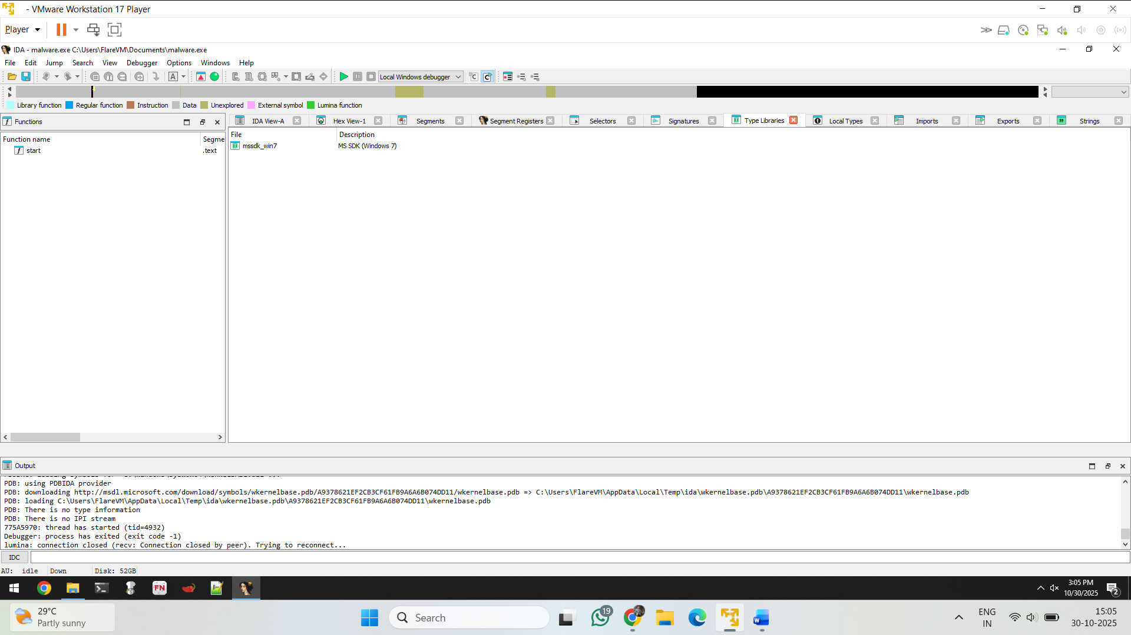

Library – mssdk_win7 ------ MS SDK ( windows 7)

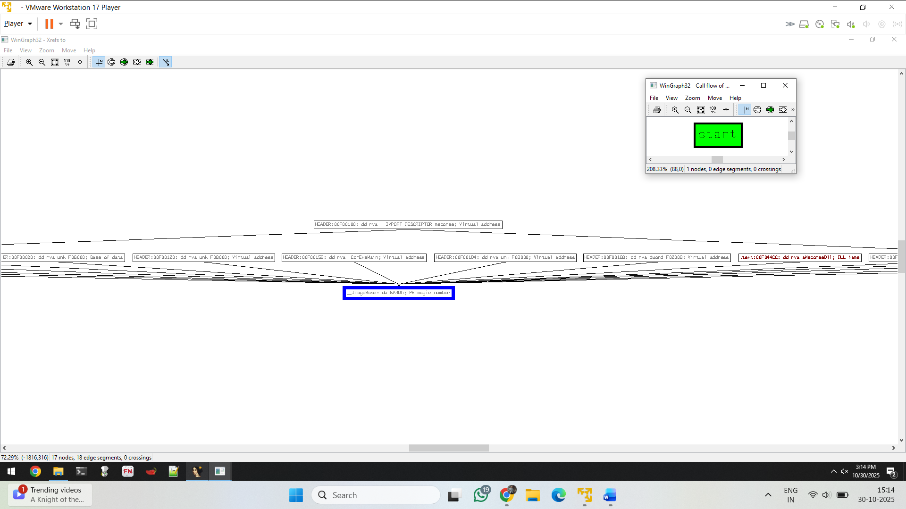

Hidden reference – image base -- work flow

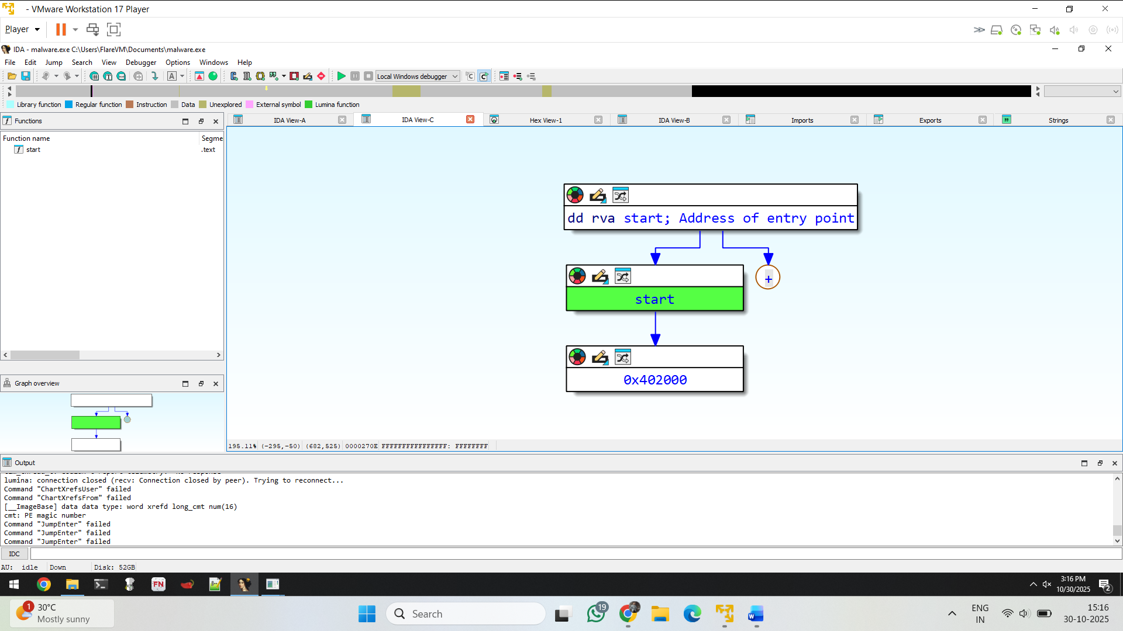

Graph of the application and it contains the hidden reference i.e in the + icon

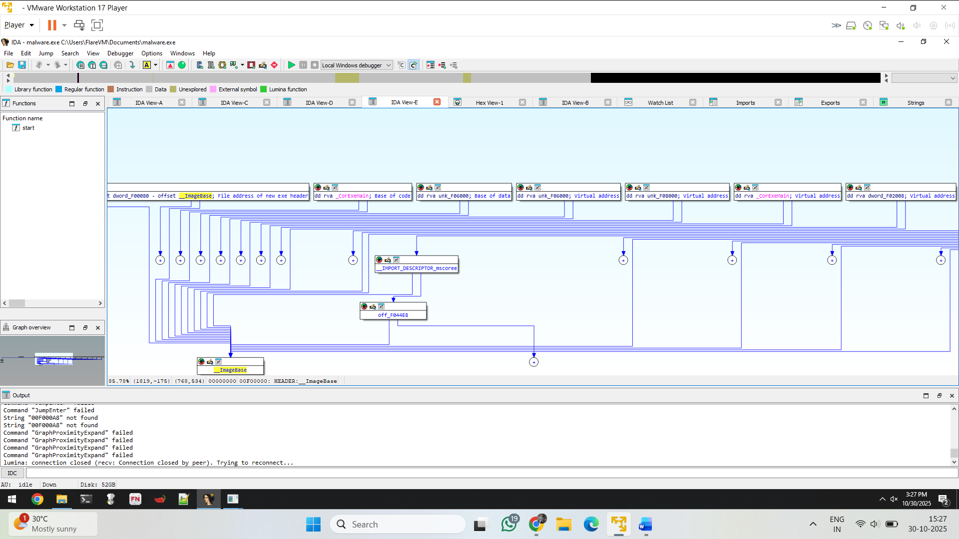

After view the hidden reference its shows the exact graph of workflow of the hidden(image base) malware

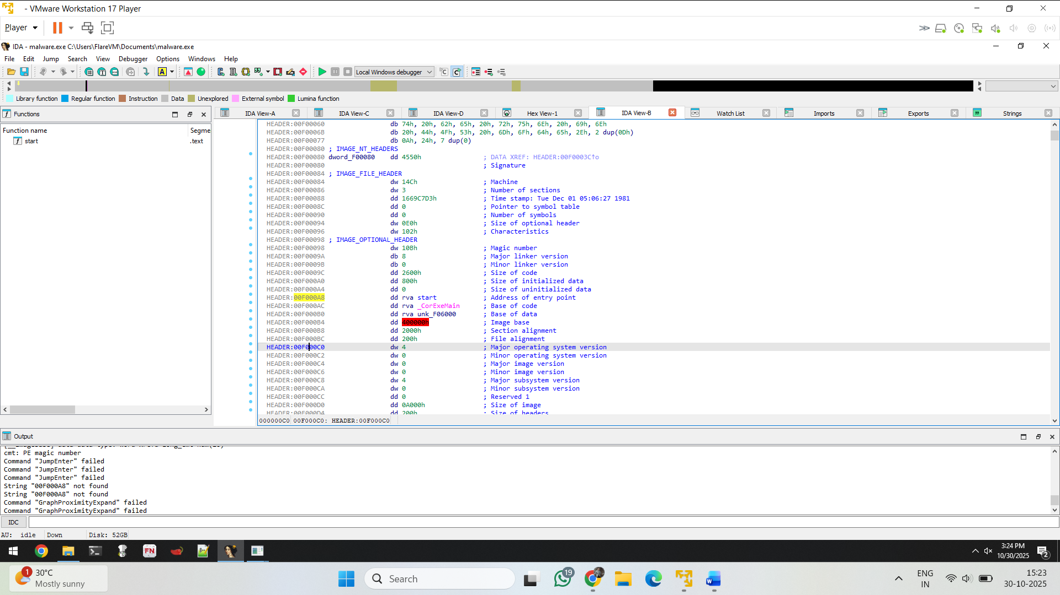

In above red icon displays the image base of hidden of the header

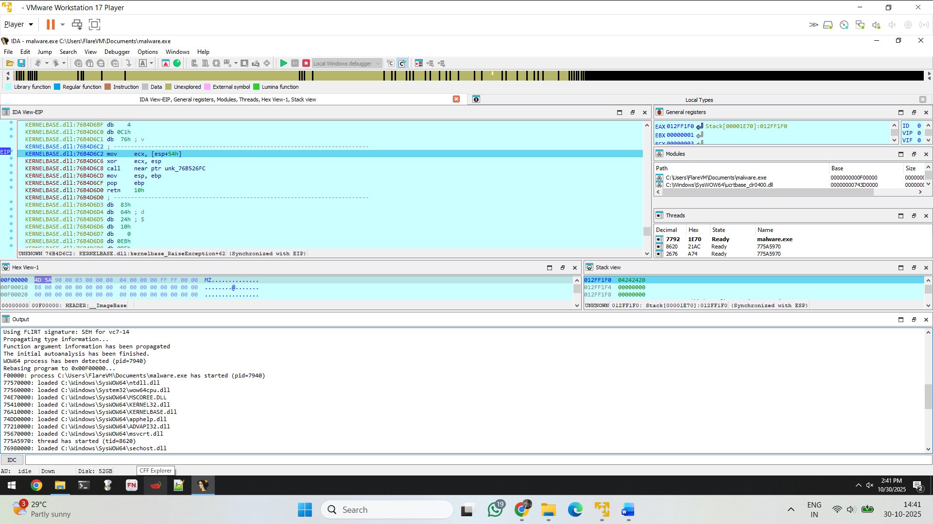

In threads 7792 – malware .exe

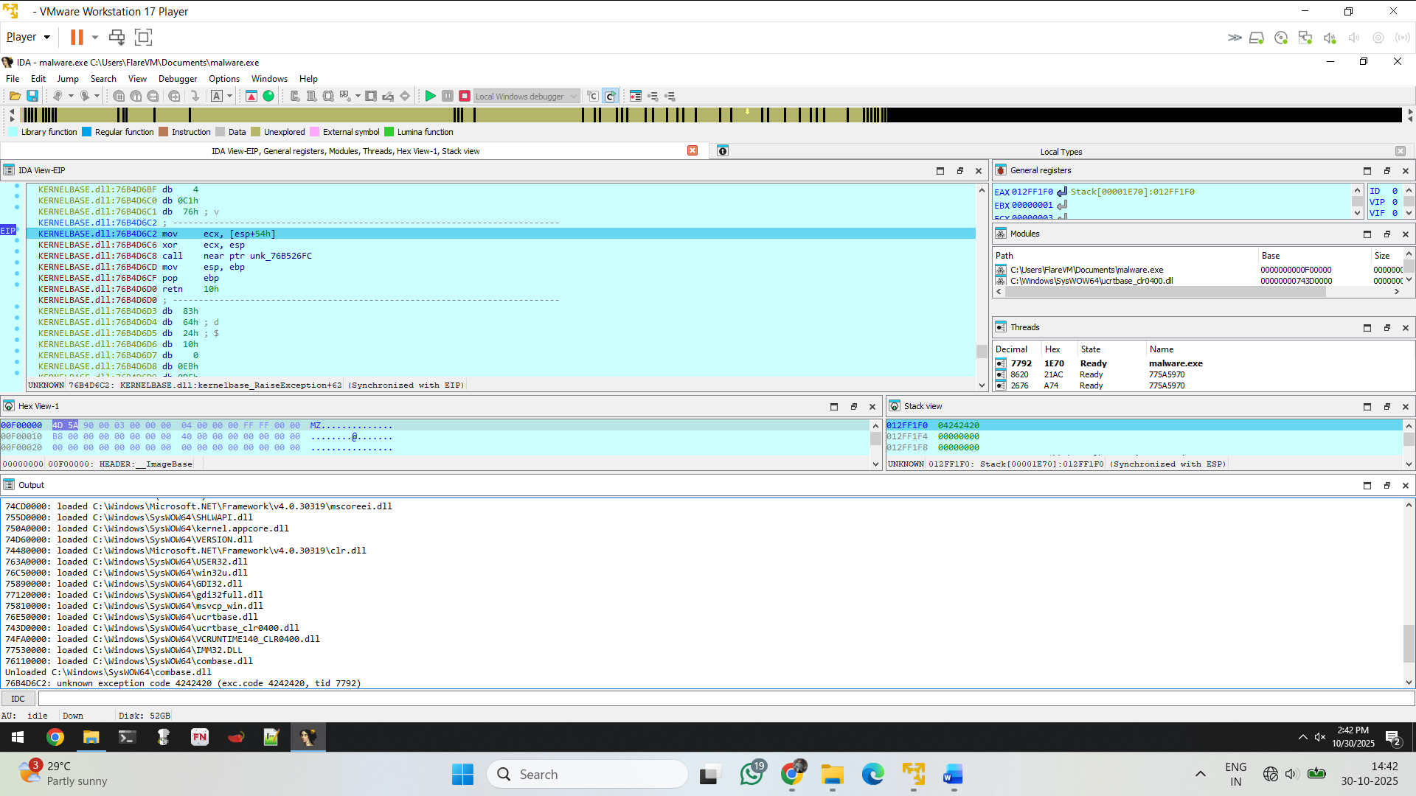

In below we can see some dll are loaded during the debugging process eg. Win32.dll, user32.dll.., etc

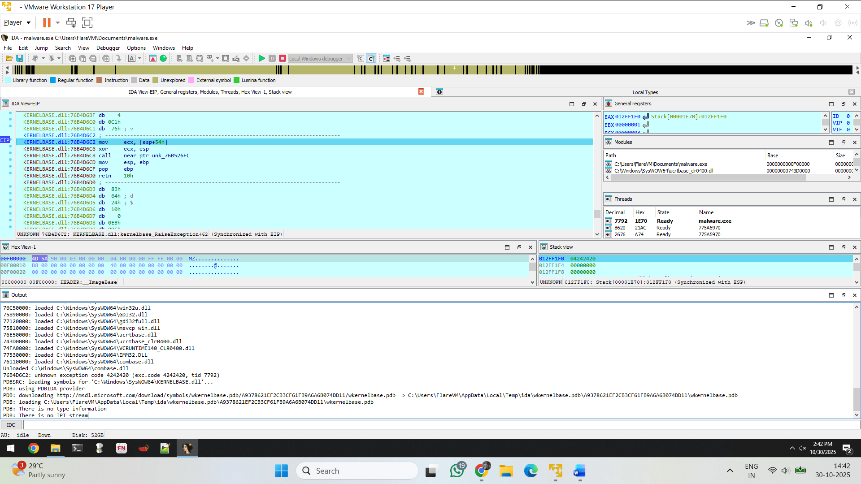

Imp things that it loads the PDB from wkernelbase etc,,

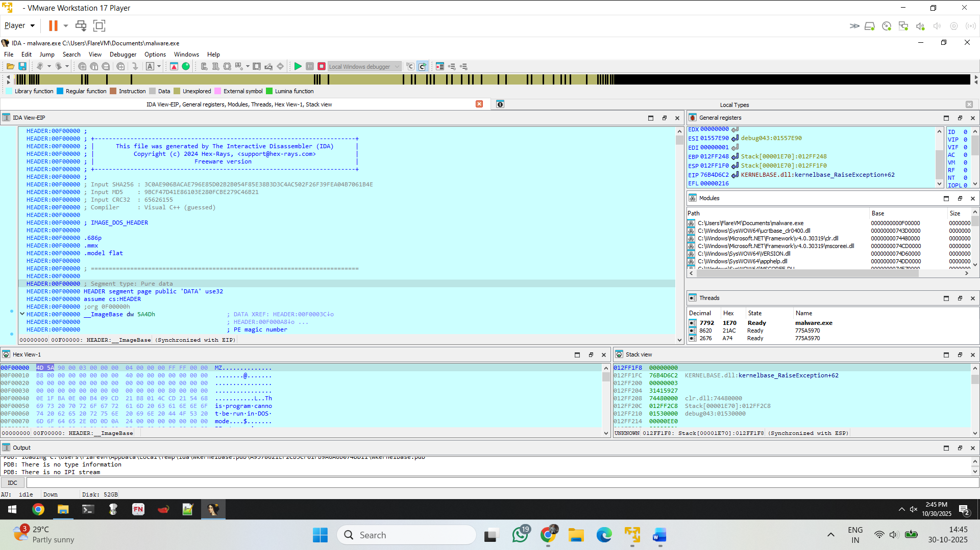

In stack view it loads kerenelbase.dll and raiseException+62

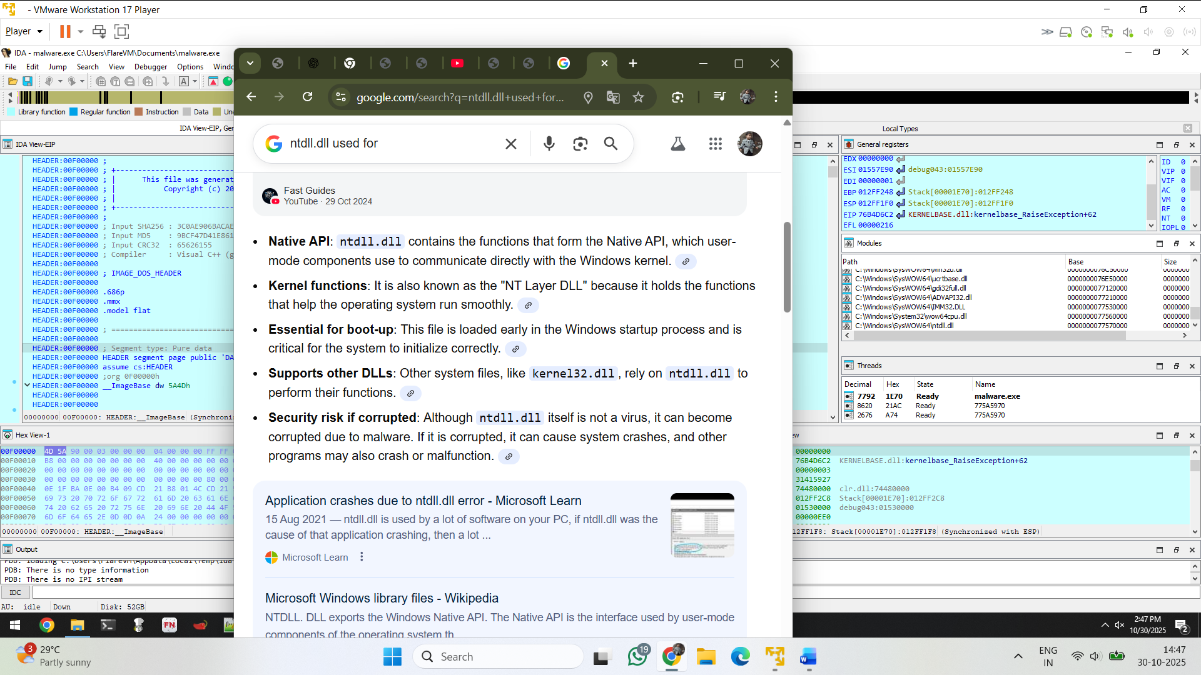

ntdll.dll is a crucial Windows system file that contains the [Native API](https://www.google.com/search?sca_esv=f4f4d625b74d76fe&rlz=1C1VDKB_en-GBIN1073IN1073&sxsrf=AE3TifPrHd3cTwoTOCWzqWHs5_X8JnN6aQ%3A1761815743175&q=Native+API&sa=X&sqi=2&ved=2ahUKEwjllKCMy8uQAxXbT2wGHcMSA1cQxccNegQIEBAB&mstk=AUtExfClOyFPCmqO_huHE7yelBKU4Ge6DtqxqQbUOy9IOw2CfgPxiyMuNu_yTVj2S6OeOinqcunsQ12Q8q2a3A0ehsQ5Rivbi8Dwy8croqVf8ruRxx7fQmYJ6zBi5syLuqerjusGpqHT5QnQnom009x8w-SwJVdpBVIdRoZuHX44v4is9F6DypbYn-S5dKs22OWUN-0K2PErICI_JGzvXUG6Bt_ZuGjI4JmyiPwdo0WWx9ecPpy9WkmYA1A2VSI3O5OUfASgo4LHydlcWRQ8uwyMwA_x&csui=3), which is the low-level interface between user-mode programs and the Windows kernel. It is used to provide core functions for the operating system and is essential for the proper operation of most programs. Since it is a core system file, it should never be deleted or modified by users

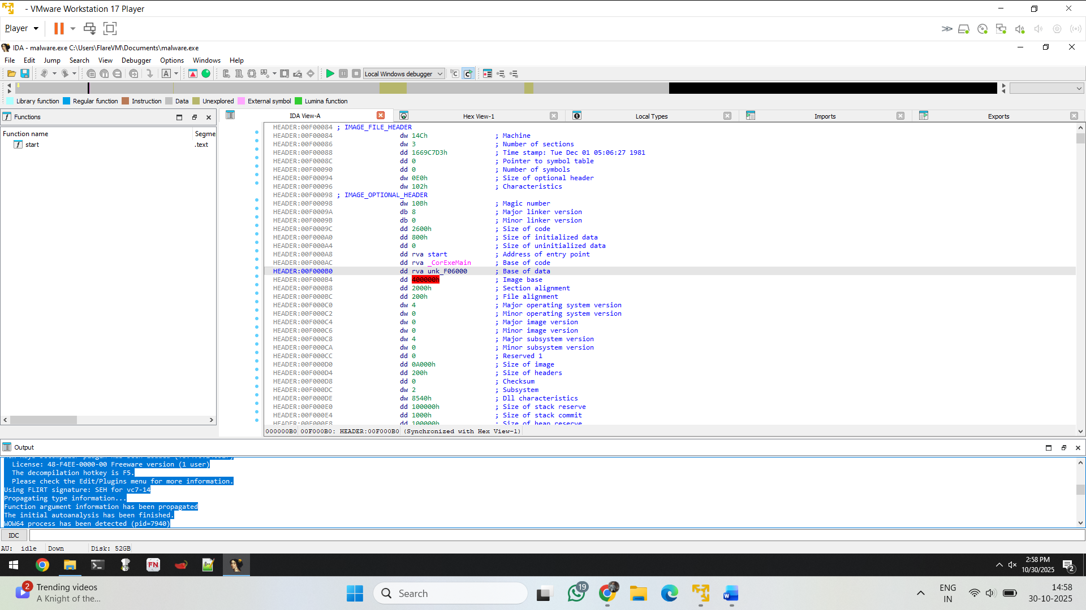

2 question :

Volatility 3 ram dump analysis

1. Cmd : python vol.py -f "C:\Users\FlareVM\Documents\Ram Dump\memdump.mem" windows.info

Getting information about the machine of during the ram dump.

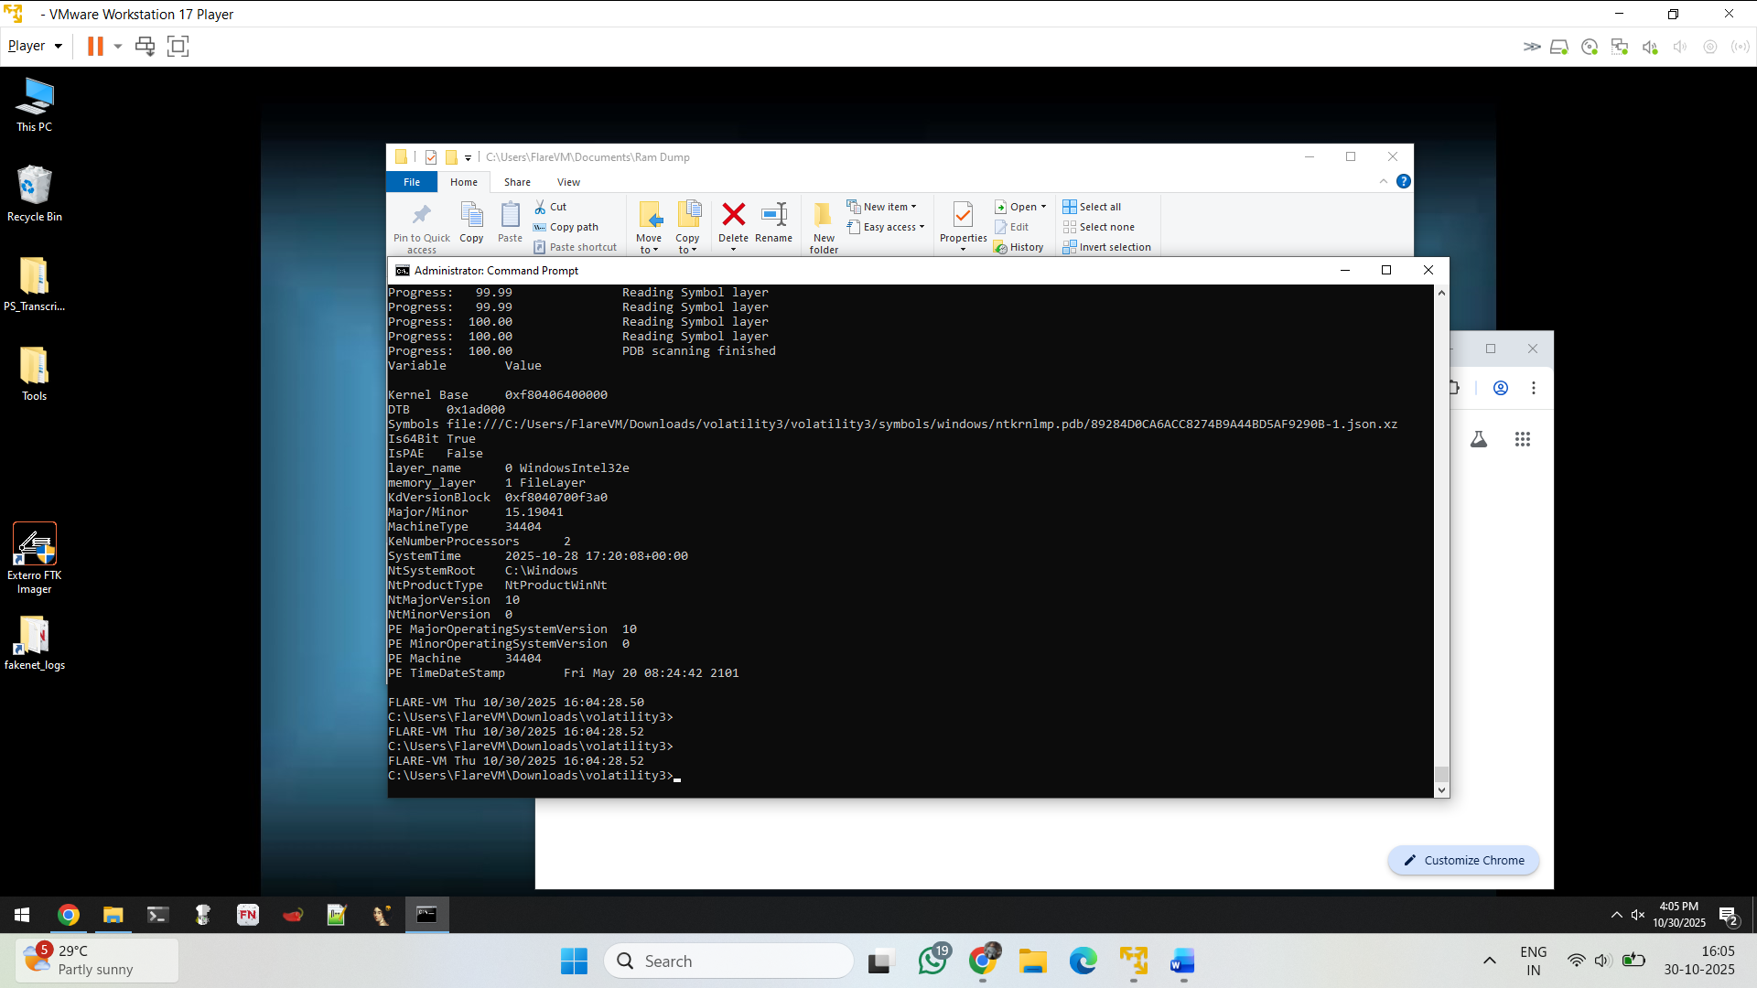

**Parsed Output (Cleaned Up)**

| **Field** | **Value (approx.)** | **Description** |
| --- | --- | --- |
| **Kernel Base** | 0xf804e64ee000 | The **base virtual address** of the Windows kernel (ntoskrnl.exe) in memory. All kernel-mode symbols and modules are loaded relative to this. |
| **PsLoadedModuleList** | 0xf804e670f3a0 | The address of the **linked list of loaded kernel modules** (drivers, kernel components). Volatility uses this to enumerate modules. |
| **Symbols** |  | Volatility indicates whether it could find **symbol information (PDB)** for debugging/translation of kernel structures. |
| **Is64Bit** | True | Confirms this is a **64-bit Windows memory image**. |
| **IsPAE** | False | PAE (Physical Address Extension) is not used (common for 64-bit systems, only 32-bit uses PAE). |
| **Layer Name** | memory_layer | Internal Volatility reference — the analysis layer used to interpret raw memory. |
| **KdVersionBlock** | — | Kernel debugger version block — structure holding OS version/build info for kernel debugging. |
| **Major/Minor Version** | 10.x | Indicates this is **Windows 10**. |
| **Machine Type** | Intel x64 (0x8664) | Architecture type — confirms x64 processor type. |
| **Windows Internal Version** | 10.0.19041 | Internal build number (Windows 10 version 2004 / 20H1). |
| **KeNumberProcessors** | 2 | Number of **logical processors (CPU cores)** at time of dump. |
| **System Time** | 2025-10-28 | Timestamp from the system at the moment the dump was taken. Useful for timeline correlation in forensics. |
| **NtSystemRoot** | C:\Windows | The root directory of the Windows installation in the memory image. |
| **Product Type** | NtProductWinNt | Indicates this is a **Workstation** edition (not Server or Domain Controller). |
| **PE Major/Minor Operating System Version** | 10.0 | Matches the Windows kernel version — confirms consistency with OS version. |
| **PE Machine** | 0x8664 | The PE header field confirming x64 architecture. |
| **PE TimeDateStamp** | Fri May 29, 2020 | The build date/time of the kernel image (ntoskrnl.exe) — matches Windows 10 version 2004. |

This metadata means your memory dump was taken from a **Windows 10 x64 system (build 19041)** with **2 logical CPUs**, and the system time when captured was **October 28, 2025**.  
Volatility correctly identified the kernel base and module list, which means you can now

Get the process id and offset of during the ram dump

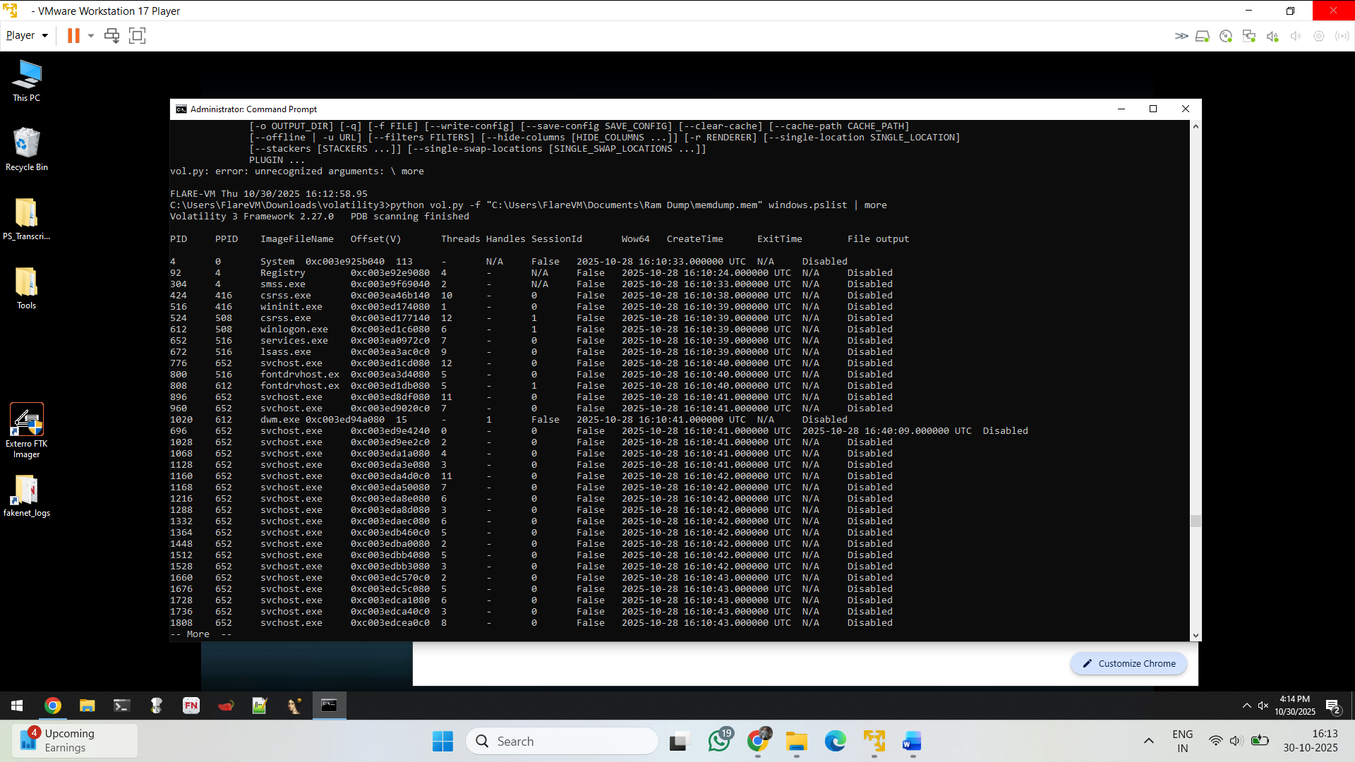

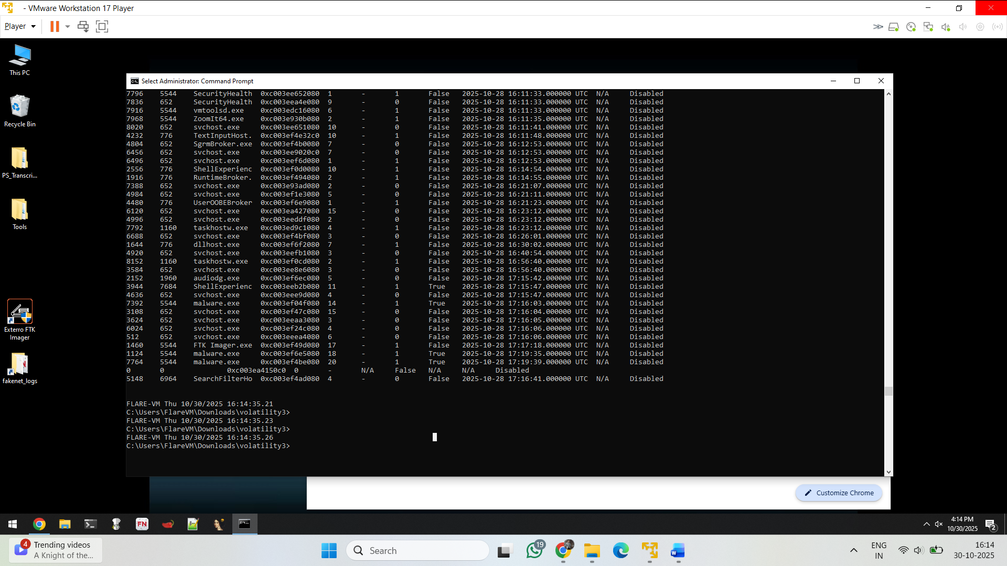

1) pid 3944 --> 7684 shell experience

2) pid 1124 7764 --> 5544 malware .exe

2) python vol.py -f "C:\Users\FlareVM\Documents\Ram Dump\memdump.mem" windows.pslist | select-string "chrome"

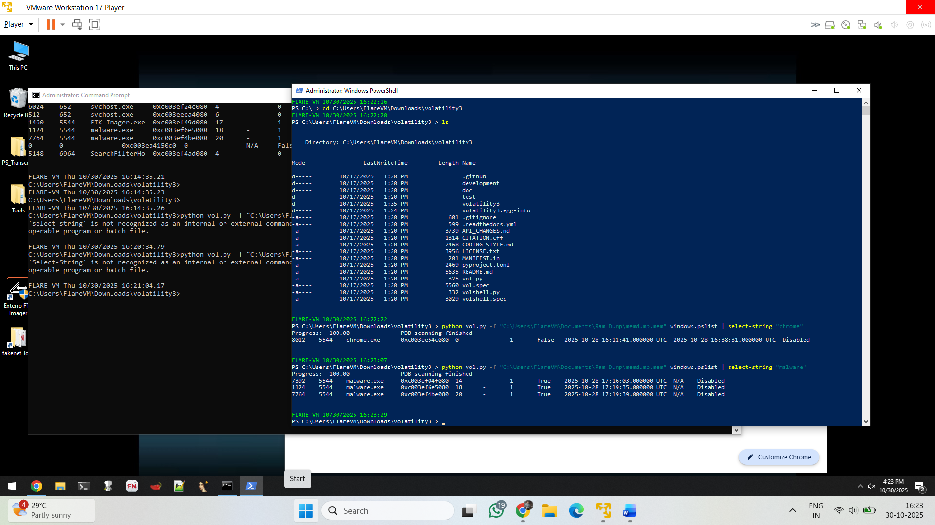

**4) Show help for a plugin**

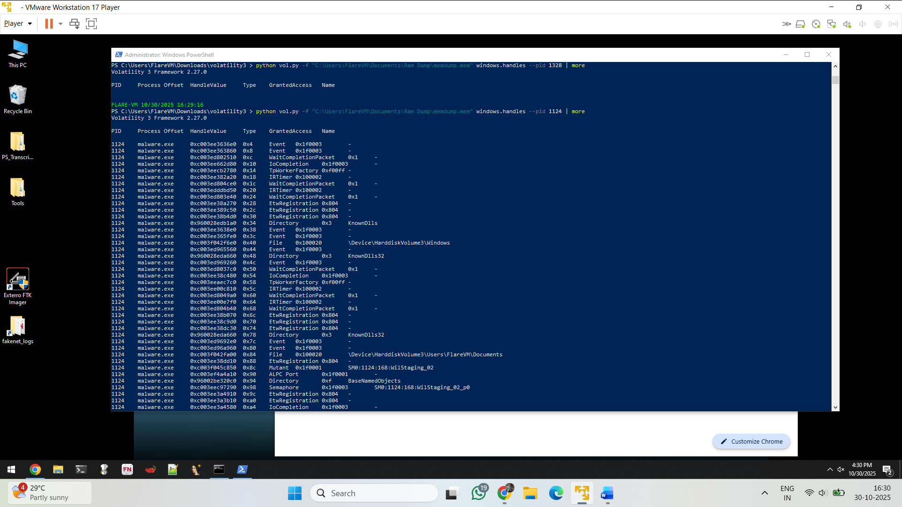

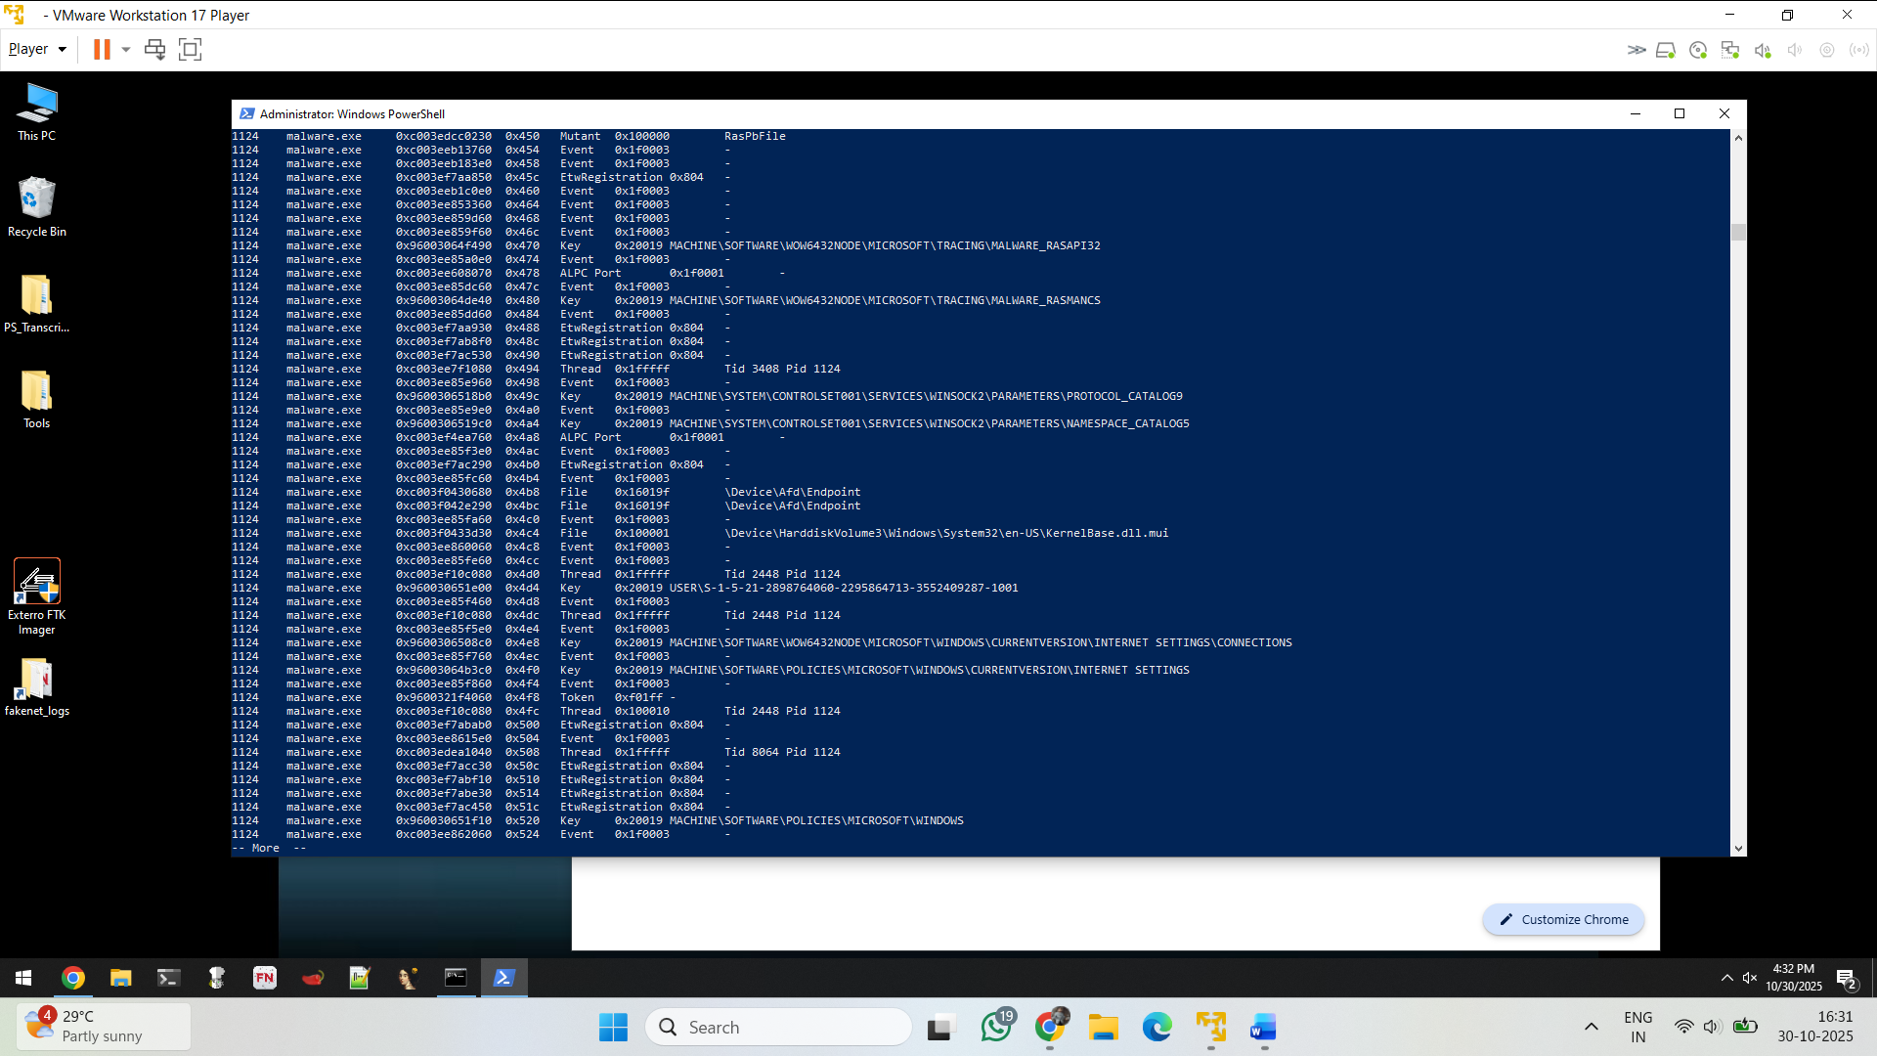

Kernelbase.dll call here for transferring the file

**6) Filter handles output for File handles**

python vol.py -f "C:\Users\FlareVM\Documents\Ram Dump\memdump.mem" windows.handles --pid 1124 | select-string "File" | more

Purpose: show only file-related handles.

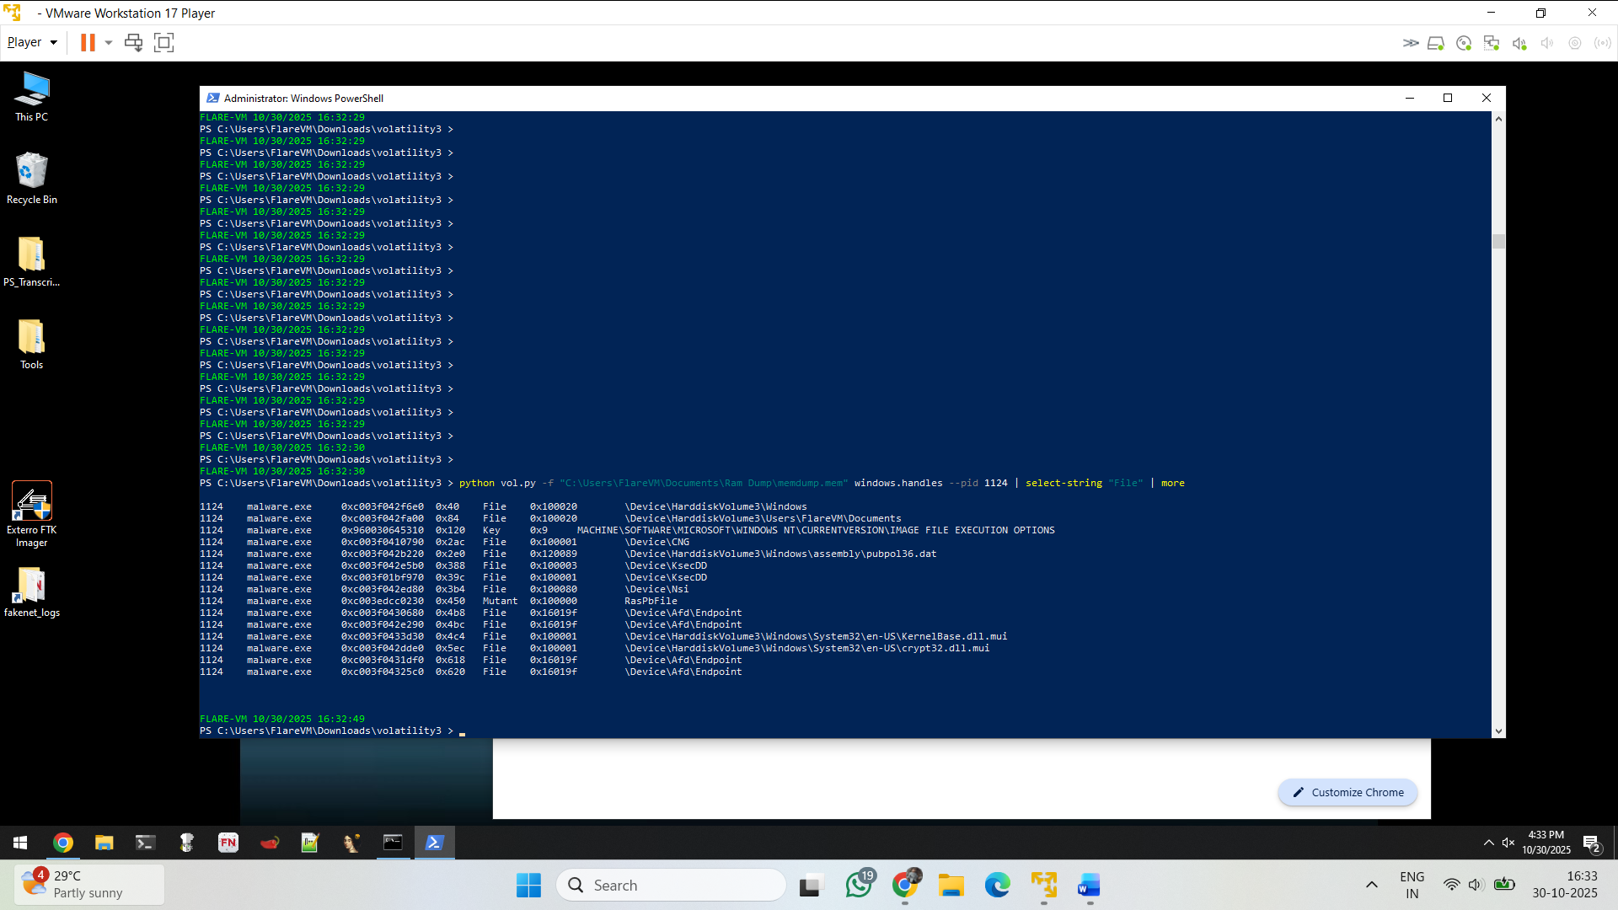

Crypt32.dll is called to do the

This command lists **all open handles** (objects like files, registry keys, sockets, etc.) for the **process with PID 1124** (in my case, ShellExperienceHost.exe) and filters the output to show **only file-related handles**.

**Explanation:**

* -f "memdump.mem" → specifies the memory dump file.
* windows.handles → Volatility 3 plugin that enumerates handle objects (like files, keys, mutexes, pipes, etc.).
* --pid 1124 → limits the search to a specific process (helps narrow down analysis).
* | select-string "File" → PowerShell filter to show only handles of type **File**.

**Why we use it:**

This step is used to:

* Identify which **files or directories** a process was interacting with.
* Detect suspicious or malicious file access (e.g., temporary payloads, encrypted data, deleted malware files).
* Extract file **virtual addresses (VA)** for later use in windows.dumpfiles.

2 malware --- 3944

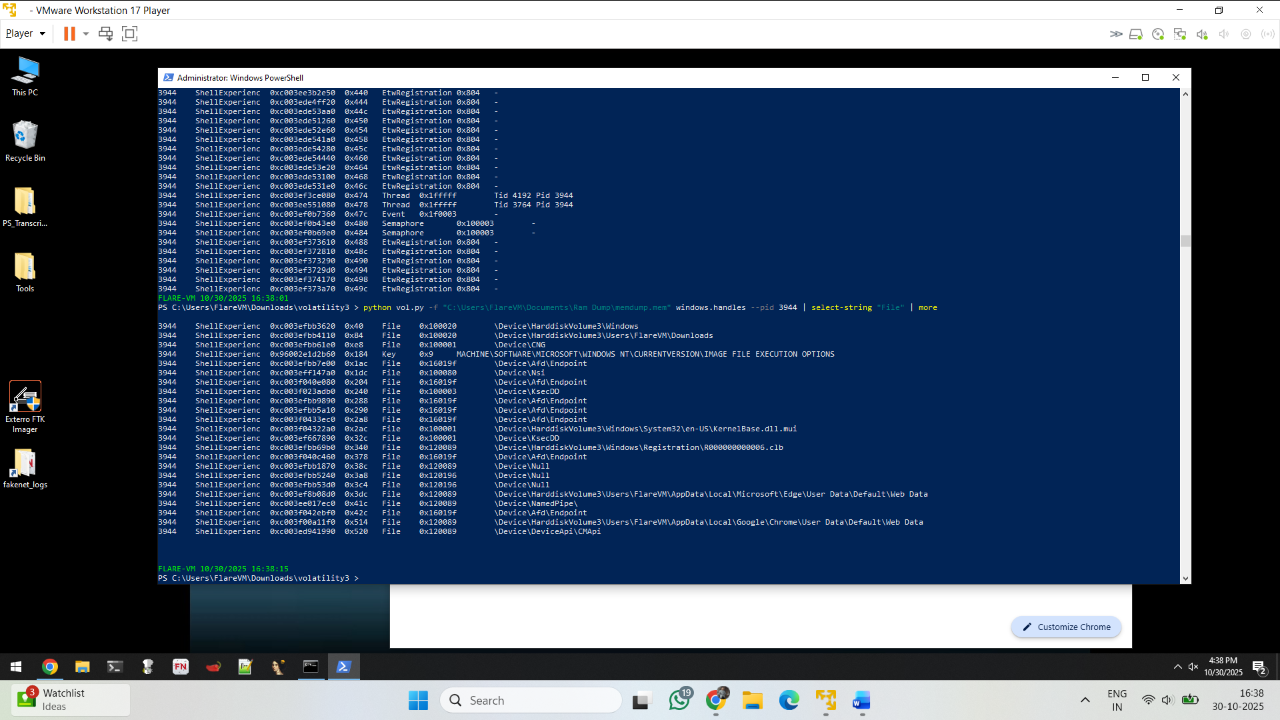

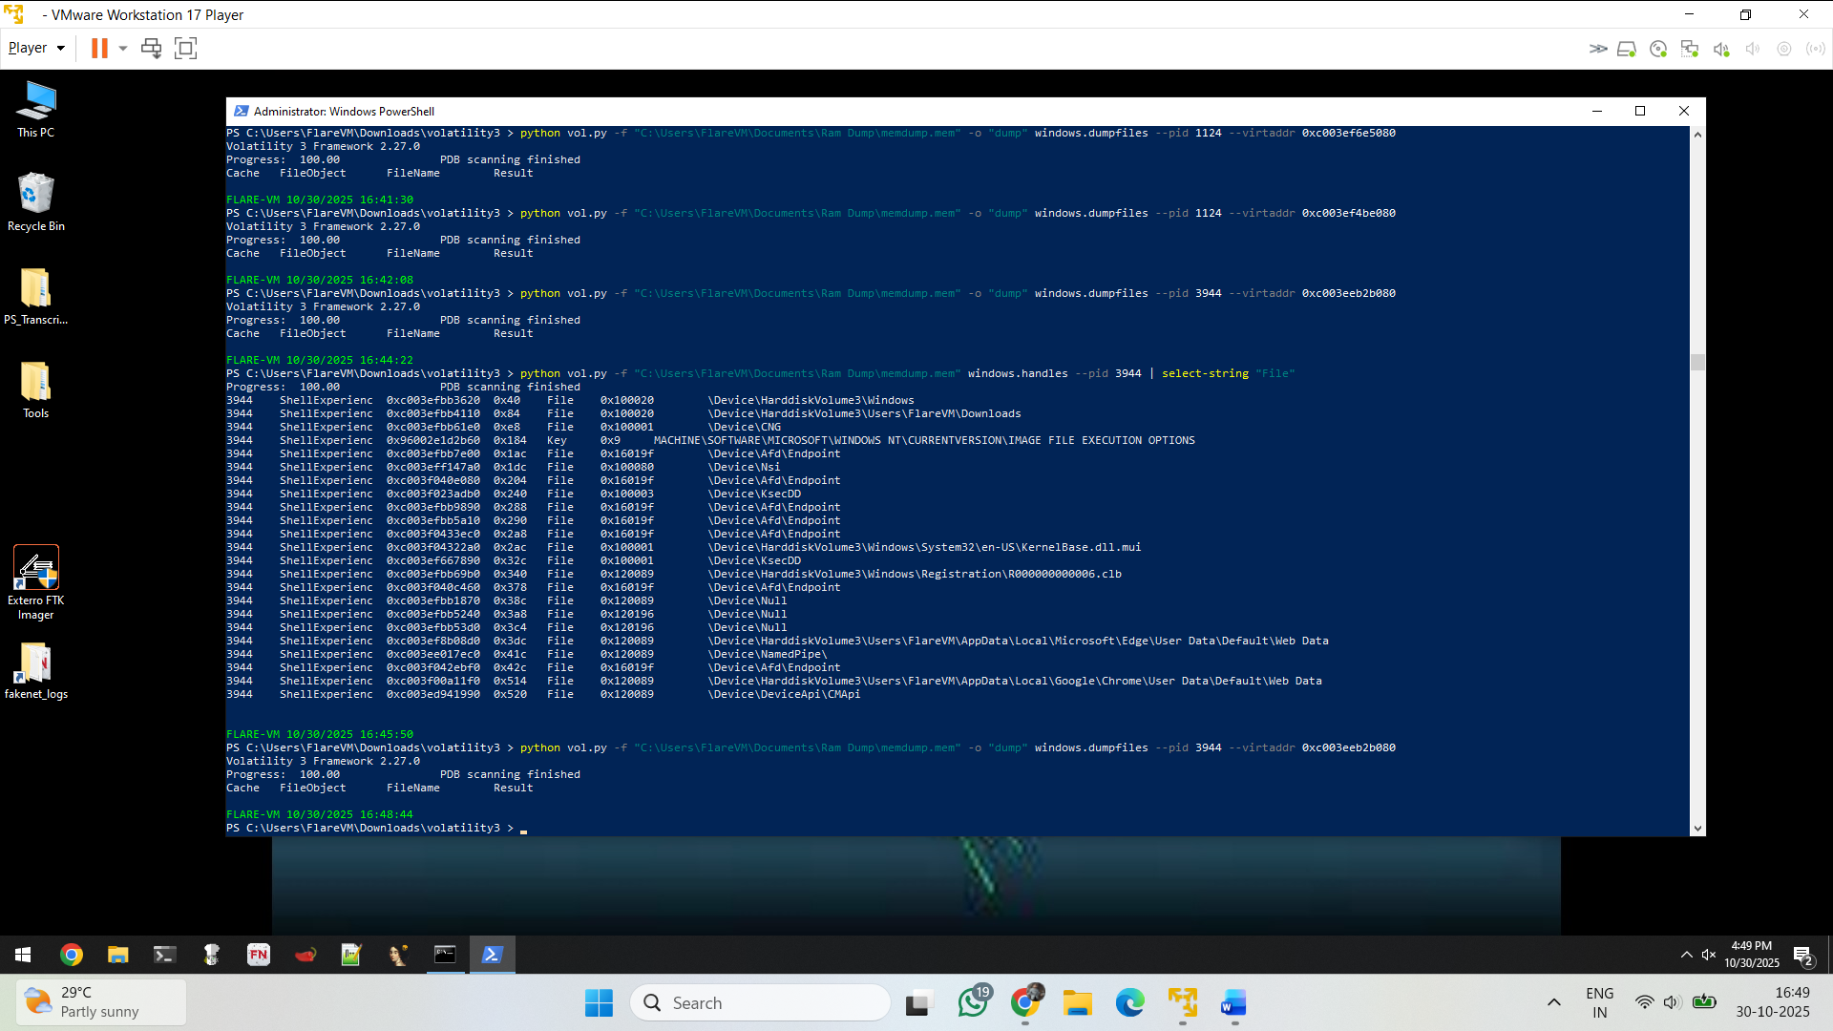

This command **extracts (dumps)** a specific file from memory using its **virtual address (VA)** found in the previous step.

**Explanation:**

* windows.dumpfiles → plugin that extracts file data directly from memory.
* --pid 3944 → again targets the same process.
* --virtaddr 0xc003eeb2b080 → this address points to the **FileObject** structure in memory for that specific file.
* -o "dump" → specifies an output directory where the dumped file will be saved.

**Why we use it:**

This is used to **recover a file that was opened or loaded in memory**

Net scan while doing network identify the TCP 4 connection that IP

192.168.254.128

Here commonly use UDP first (for discovery/NAT traversal/beaconing) and then open a TCP connection for reliable command-and-control or exfiltration.

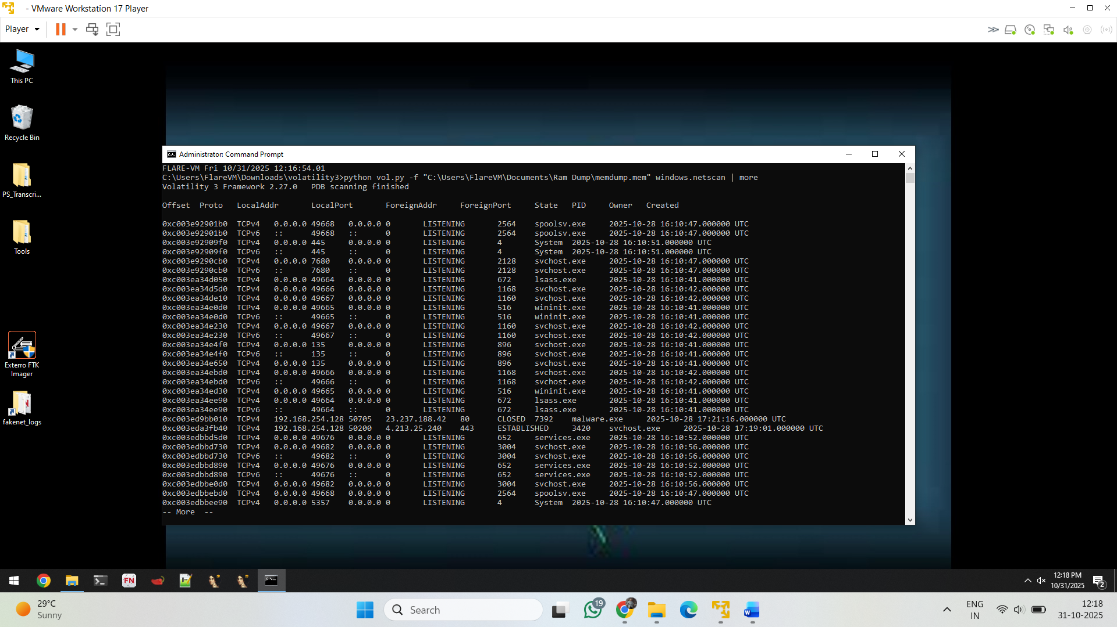

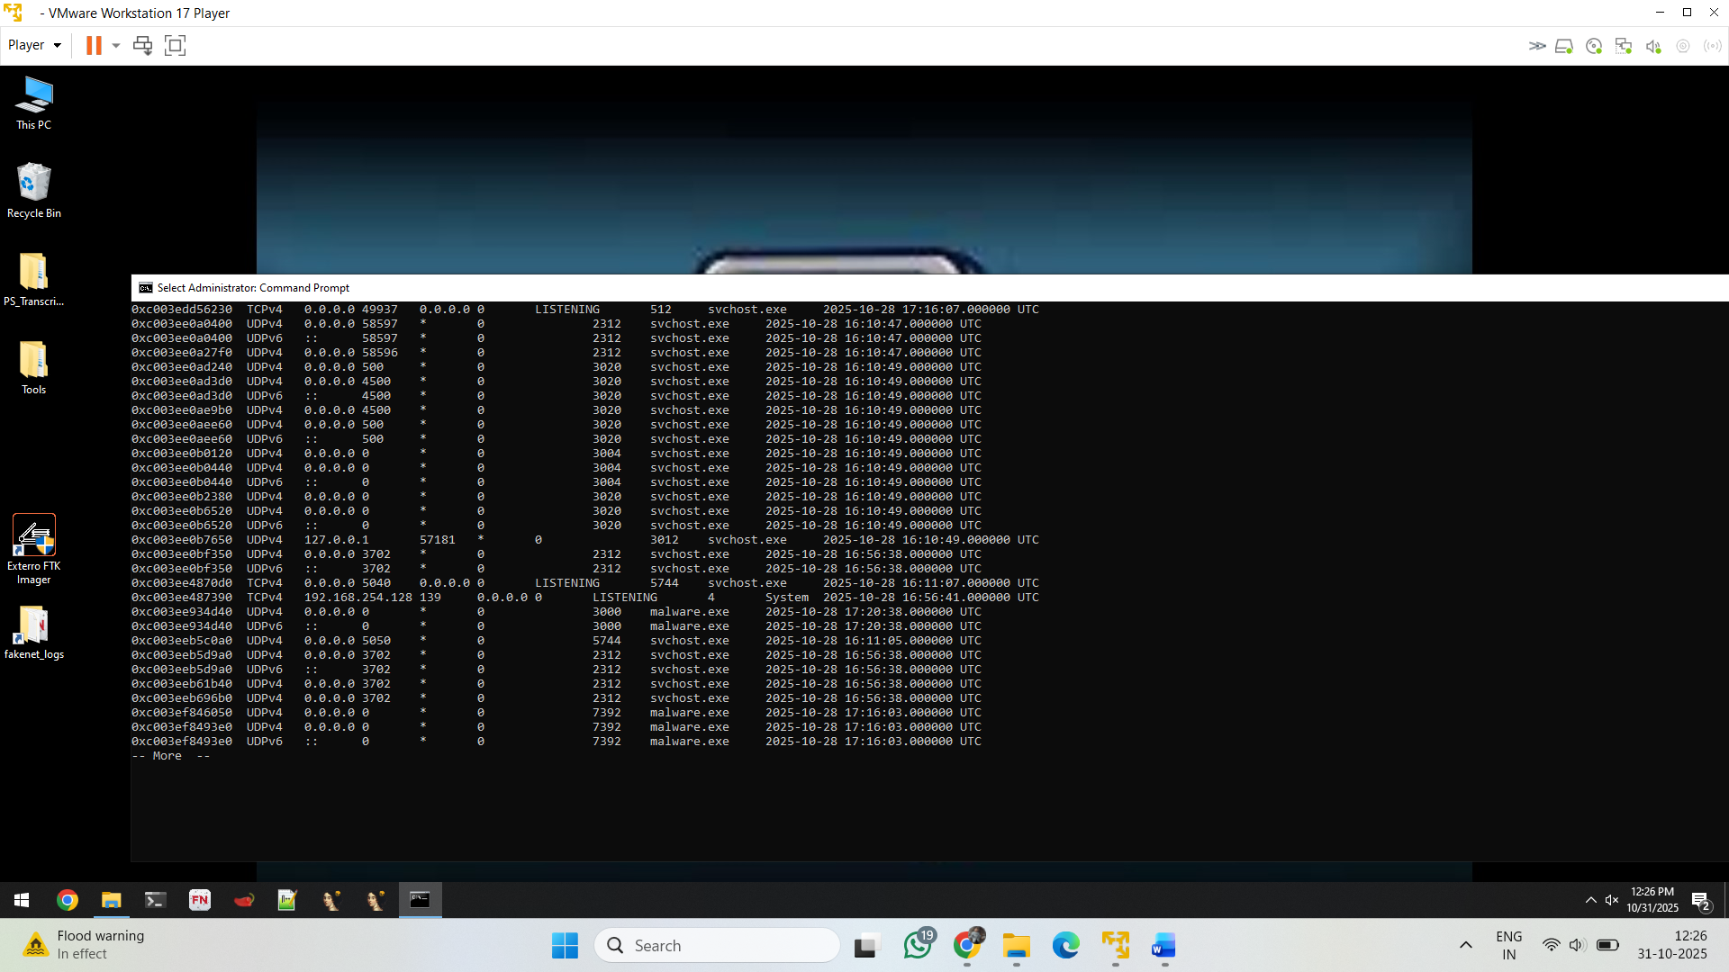

Udp connection is establish then it is done

* Note : **UDP is lightweight & fire-and-forget.** Good for quick beacons (small packets) to see if a controller is reachable.
* **NAT traversal / hole punching.** UDP hole punching (and STUN) can create a path through NATs; once the path exists, TCP or higher-level protocols can be used.
* **Stealth / opportunism.** UDP can slip through poorly filtered firewalls; after confirming reachability, the malware upgrades to TCP for reliable transfer.
* **Protocol framing.** Some malware uses UDP for discovery and negotiation (which port, protocol version, auth), then opens an authenticated TCP session (or QUIC over UDP).
* **Fallback & multi-channel C2.** If TCP is blocked, the malware may try UDP or DNS; or do UDP beacon → TCP payload.

Examples: beacon (UDP) → rendezvous server responds → client opens TCP backchannel to send large files or interactive C2.

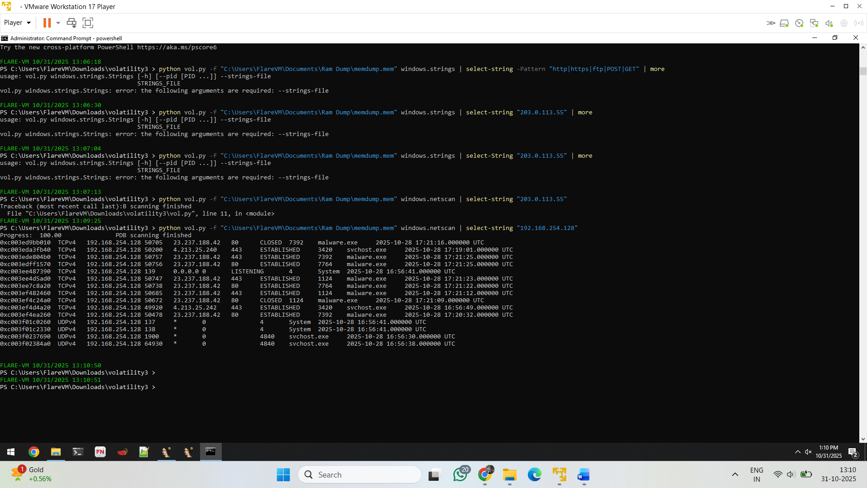

Search the ip with string identify the connection

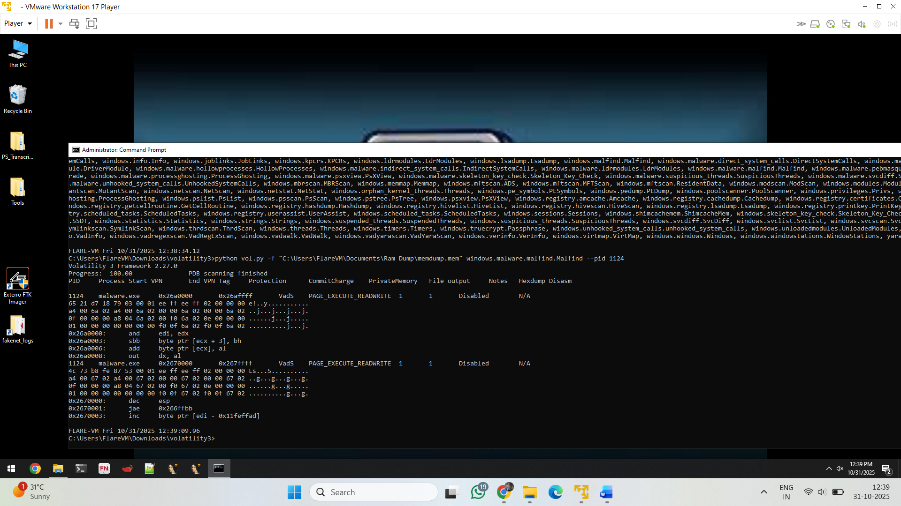

Assemble language and,jae..etc.

**Finding**: malfind reported a private RWX memory region in PID 1124 containing probable shellcode.

Ps tree of the pid –1124

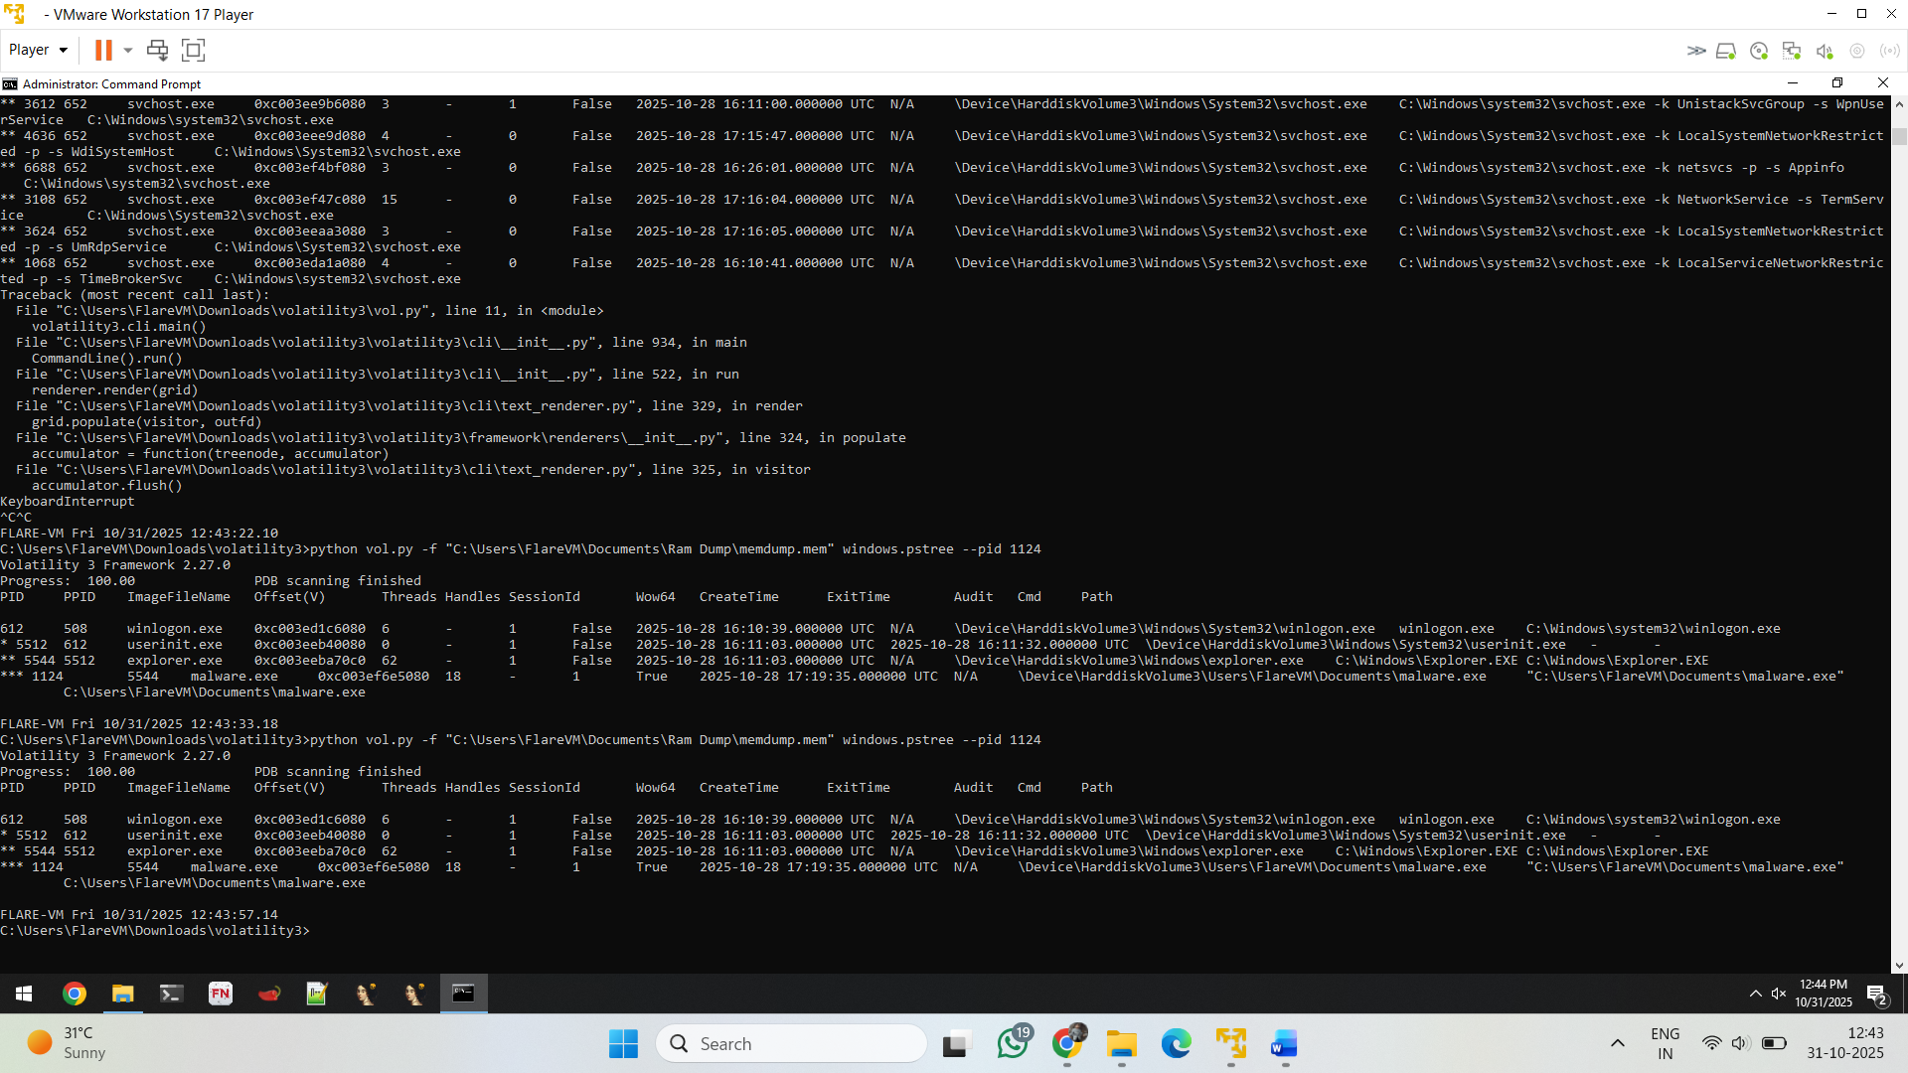

**Process tree finding (Volatility windows.pstree)**  
Memory image: C:\Users\FlareVM\Documents\Ram Dump\memdump.mem  
Volatility plugin: windows.pstree  
Observation: malware.exe (PID **5544**) is present as a child process under the user shell (explorer.exe). The process path is C:\Users\FlareVM\Documents\malware.exe. Process create time recorded by pslist is **2025-10-28 16:11:32 UTC**.  
Interpretation: Execution from a user profile directory and parented by explorer.exe is consistent with a user-level dropper or socially-engineered execution. This is suspicious and warrants further evidence collection (memory region dump, module enumeration, network correlation).

windows.ldrmodules (and related DLL/module plugins)

